## **Structure**

Bookmark this page

**Part 1 - Introduction to Power BI**

* **What is Power BI?**
  + Brief description of tool.
  + Where is this being used?
  + Purpose of this tool
* **What are the different platforms? Desktop, Service, Mobile**
  + What are these 3 Platforms? Definitions
  + How is it connected to each other? Include a diagram.
  + Significance of the 3
* **Installation Steps**
  + Steps to install Power BI Desktop application.
  + Video or Screenshots of the process

**Part 2 - Connecting to data sources and Creating basic charts and visuals**

* **Different Sources overview**
  + Overview of Get Data and Refresh Data option from Home Tab
  + What are the different sources available for connection?
  + What happens when the refresh button is clicked?
  + Overview of Import Method and Direct Query Method when connecting to data.
* **Steps to connect to sample dataset**
  + Demo with steps connecting to sample dataset from Power BI
* **Steps to connect to csv/excel file**
  + Demo with steps connecting to Excel and CSV files
  + Demo with data refresh
* **Introduction to 3 views - report, model,data**
  + Describe Report, Model and Data view using screenshots and brief about each of them
  + Overview of panes - Visualization, Fields
  + Overview of Charts and Fields and Format section from Visualization pane
* **Bar and column chart**
  + Demo with bar and column chart with an example exercise
  + Describe Visual Tooltip
* **Pie chart/ Donut chart**
  + Demo with Pie or Donut chart with example exercise
* **Clustered and stacked chart**
  + Describe how to create these charts - Drag & Drop and by selecting column options
  + Describe different options available on visuals (Header tooltip)
  + Demo with Clustered & Stacked chart with an example exercise
* **Line / Area chart**
  + Describe steps to create - single line, multiple lines
  + Demo with Area and line chart for single and multi line
* **Slicers - variations like list, dropdown, horizontal, range**
  + What are slicers?
  + How is it useful?
  + How to create slicers and what type of fields are suitable for this?
  + Demo with Select all , multi select single select slicers
  + Demo with example and also with variation and its usefulness (List, Dropdown, Horizontal, range)

**Part 3 - Cleansing data with Query Editor**

Overview of Query Editor and steps on how to open this window from app

* **Filtering**
  + Describe how to filter data similar to excel filtering
  + Explain what happens to the visuals when data is filtered
* **Duplicate removal**
  + Describe overview of Home tab in query editor
  + Demo on How to remove duplicates
* **Remove nulls or errors**
  + Describe how to identify which columns have nulls or errors
  + Demo on How to remove errors from columns
* **Replacing Values**
  + Overview of Transform tab
  + Demo on how to replace values - text and numbers

**Part 4 - Creating Report by combining all visuals**

* **Demo with exercise to put all charts together into a single report**

## **Dataset Explanation**

Bookmark this page



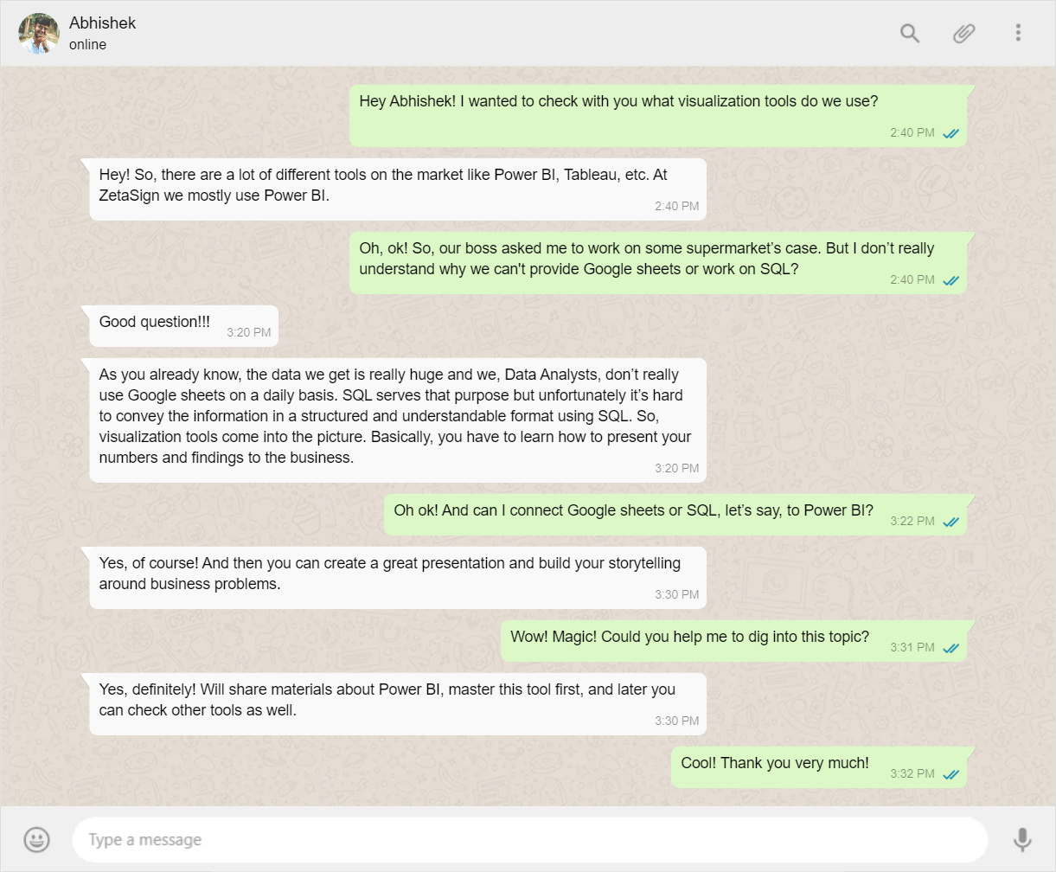

**Demo Dataset**

A Student Survey form which captures the basic information of the student and details about students’ activity.

Download dataset from [here](https://drive.google.com/file/d/1Z3U-dkxLthrpMJH6DGMv6E6XoXZt5-CY/view?usp=sharing)

Table Description

| **Sl.No** | **Column Name** | **Column Description** |
| --- | --- | --- |
| 1 | Gender | student's gender (nominal: 'Male' or 'Female’) |
| 2 | Nationality | student's nationality |
| 3 | Place of birth | student's Place of birth |
| 4 | Educational Stages | educational level student belongs (nominal: lower level,MiddleSchool,HighSchool) |
| 5 | Grade Levels | grade student belongs |
| 6 | Section ID | classroom student belongs |
| 7 | Topic | course topic |
| 8 | Semester | school year semester (nominal: First, Second) |
| 9 | Relation | Parent responsible for student (nominal:mum, father) |
| 10 | Raised hand | how many times the student raises his/her hand on classroom |
| 11 | Visited resources | how many times the student visits a course content |
| 12 | Viewing announcements | how many times the student checks the new announcements |
| 13 | Discussion groups | how many times the student participated on discussion groups |
| 14 | Parent Answering Survey | parent answered the surveys which are provided from school or not |
| 15 | Parent School Satisfaction | the Degree of parent satisfaction from school |
| 16 | Student Absence Days | the number of absence days for each student (above 7 , below 7) |
| 17 | index | Unique ID |

**Demo dataset Sample**

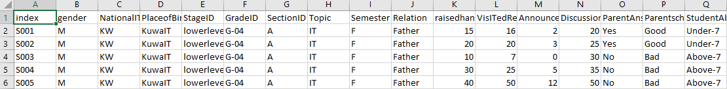

#### **Guided Dataset**

Supermarket invoices are collected and stored in a table to monitor products sold and income generated.

Download dataset from [**here**](https://lms.codinginvaders.com/assets/courseware/v1/6ab354ffde3d35206dc78a20bc516495/asset-v1:CodingInvaders+DATEST+1+type@asset+block/supermarket_sales.csv)

Table Description

| **Sl No.** | **Column Name** | **Column Description** |
| --- | --- | --- |
| 1 | Invoice ID | Computer generated sales slip invoice identification number |
| 2 | Branch | Branch of the store |
| 3 | City | City which the store is located |
| 4 | Customer type | Type of customers, recorded by Members for customers using member card and Normal for without member card |
| 5 | Gender | Male or Female |
| 6 | Product line | Type of products |
| 7 | Unit price | Price of single product |
| 8 | Quantity | Quantity of the products sold |
| 9 | Tax 5% | 5% of tax on price |
| 10 | Total | Total price including tax |
| 11 | Date of purchase | Date when the invoice was generated |
| 12 | Time | Time when the invoice was generated |
| 13 | Payment | Type of payment (credit card, ewallet or cash) |
| 14 | cost_of_goods_sold | Cost of goods sold excluding tax |
| 15 | gross margin percentage | Gross margin % |
| 16 | gross income | Gross Income |
| 17 | Customer Rating | Rating given by customer |

**Guided dataset Sample**

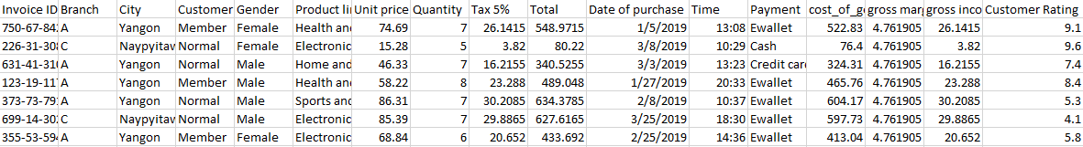

## **What is Power BI?**

Bookmark this page

**What is Power BI?**

Data plays a major role in day to day life. This data residing in any system is useless if it has no ability to communicate or to interpret. In order to obtain meaningful information from the underlying data Business Intelligence tools come into picture.

Microsoft Power BI is one of the powerful Business Intelligence tool. It is a collection of software services and apps that can be connected together to turn unrelated data into meaningful insight. Data can be lying in excel, native databases or in any warehouse, Power BI lets analysts to connect to such hybrid sources, clean and model without affecting data from source and visualize important attributes and share insights.

## **What are the different platforms? Desktop, Service, Mobile**

Bookmark this page

**What are the different platforms? Desktop, Service, Mobile**

Power BI has 3 parts - Power BI Desktop, Power BI Service and Power BI Mobile.

* Power BI Desktop - On-premise application on Windows
* Power BI Service - Online SaaS (Software as a Service) application
* Power BI Mobile - An application that can be used on Tablets/ Mobiles

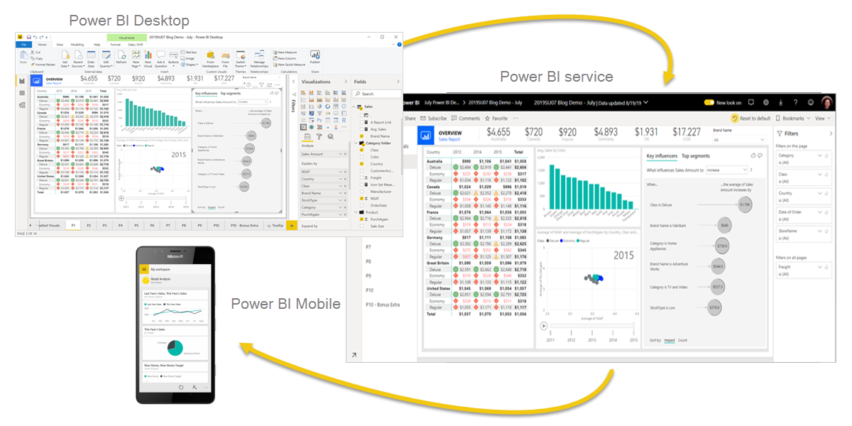

Power BI Desktop helps in building reports by connecting to various data sources. Power BI Service lets analysts create dashboards using reports and collaborate with other analysts and also share it across business teams, which then can also be viewed using Power BI Mobile app on the go.

Power BI Desktop is a free application to download and get started with data visualization. Power BI Desktop only works on Windows. Power BI Service and Mobile app requires users to have paid licenses.

This course is entirely on Power BI Desktop application and its usage.

## **Installation Steps**

Bookmark this page

**Steps to install Power BI Desktop:**

**Step 1:** Click on the website link [**here**](https://www.microsoft.com/en-us/download/details.aspx?id=58494)

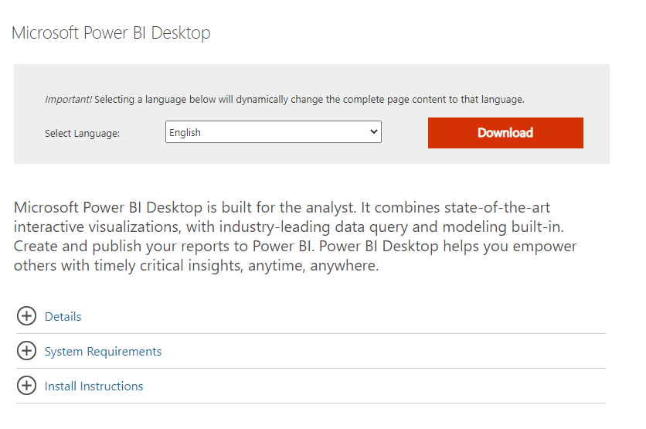

**Step 2:** Click on the Download button, a new window will be popped, choose the file based on windows architecture being used.

If Windows 32- bit machine then choose PBIDesktopSetup.exe, for windows 64bit- machine choose PBIDesktopSetup_x64.exe file and click on “Next” button.

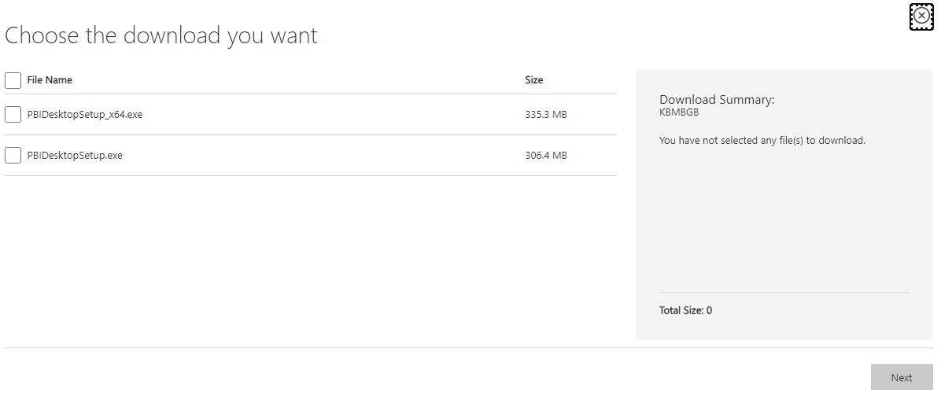

**Step 3:** After completion of download, open file and install. Refer to the video below for detailed steps.

[Course](https://lms.codinginvaders.com/courses/course-v1:CodingInvaders+DATEST+1/course/) [Power BI Module 1](https://lms.codinginvaders.com/courses/course-v1:CodingInvaders+DATEST+1/course/#block-v1:CodingInvaders+DATEST+1+type@chapter+block@2c4c26b6002c466e8602380c081726e8) [Part 2 - Connecting to data sources and Creating basic charts and visuals](https://lms.codinginvaders.com/courses/course-v1:CodingInvaders+DATEST+1/course/#block-v1:CodingInvaders+DATEST+1+type@sequential+block@c630f3d5275849eca0eb325dd3185f99) Different Sources overview

## **Different Sources overview**

Bookmark this page

This section helps analysts to get started with the tool by connecting to a data source as it is the first step to data visualization.

Data source can be connected by these following steps,

Click Home Tab > Click on Get Data icon > Select a source



Refreshing data is necessary if the source data is updated, Power BI has a feature to refresh this data with a click.

That is by clicking on the Home tab > Click on Refresh button icon.



Power BI supports various data sources, in this module we will learn how to connect to a .csv file and also see what are the sample dataset available in Power BI.

[Course](https://lms.codinginvaders.com/courses/course-v1:CodingInvaders+DATEST+1/course/) [Power BI Module 1](https://lms.codinginvaders.com/courses/course-v1:CodingInvaders+DATEST+1/course/#block-v1:CodingInvaders+DATEST+1+type@chapter+block@2c4c26b6002c466e8602380c081726e8) [Part 2 - Connecting to data sources and Creating basic charts and visuals](https://lms.codinginvaders.com/courses/course-v1:CodingInvaders+DATEST+1/course/#block-v1:CodingInvaders+DATEST+1+type@sequential+block@c630f3d5275849eca0eb325dd3185f99) Steps to connect to sample dataset

## **Steps to connect to sample dataset**

Bookmark this page

Power BI provides a sample dataset to play around, follow these steps below to start working with a sample dataset.

**Step 1:** Open Power BI application

**Step 2:** Click on “Try Sample Dataset”

**Step 3:** A window is popped up, click on “Load Dataset”

**Step 4:** From this window, Select checkbox of the table name and click on “Load”

[Course](https://lms.codinginvaders.com/courses/course-v1:CodingInvaders+DATEST+1/course/) [Power BI Module 1](https://lms.codinginvaders.com/courses/course-v1:CodingInvaders+DATEST+1/course/#block-v1:CodingInvaders+DATEST+1+type@chapter+block@2c4c26b6002c466e8602380c081726e8) [Part 2 - Connecting to data sources and Creating basic charts and visuals](https://lms.codinginvaders.com/courses/course-v1:CodingInvaders+DATEST+1/course/#block-v1:CodingInvaders+DATEST+1+type@sequential+block@c630f3d5275849eca0eb325dd3185f99) Steps to connect to csv/excel file

## **Steps to connect to csv/excel file**

Bookmark this page

Click on ”Home Tab” > Click “Get Data” > Go to “All” > Click on “Text/CSV” > Search for CSV File from browser and Click on “Open” > click on “Load”

[Course](https://lms.codinginvaders.com/courses/course-v1:CodingInvaders+DATEST+1/course/) [Power BI Module 1](https://lms.codinginvaders.com/courses/course-v1:CodingInvaders+DATEST+1/course/#block-v1:CodingInvaders+DATEST+1+type@chapter+block@2c4c26b6002c466e8602380c081726e8) [Part 2 - Connecting to data sources and Creating basic charts and visuals](https://lms.codinginvaders.com/courses/course-v1:CodingInvaders+DATEST+1/course/#block-v1:CodingInvaders+DATEST+1+type@sequential+block@c630f3d5275849eca0eb325dd3185f99) Introduction to 3 views - report, model,data

## **Introduction to 3 views - report, model,data**

Bookmark this page

Power BI Desktop has 3 views namely, Report View, Model View and Data View.

**Report View** - This is a blank canvas which is used to draw visuals and graphs to create reports.

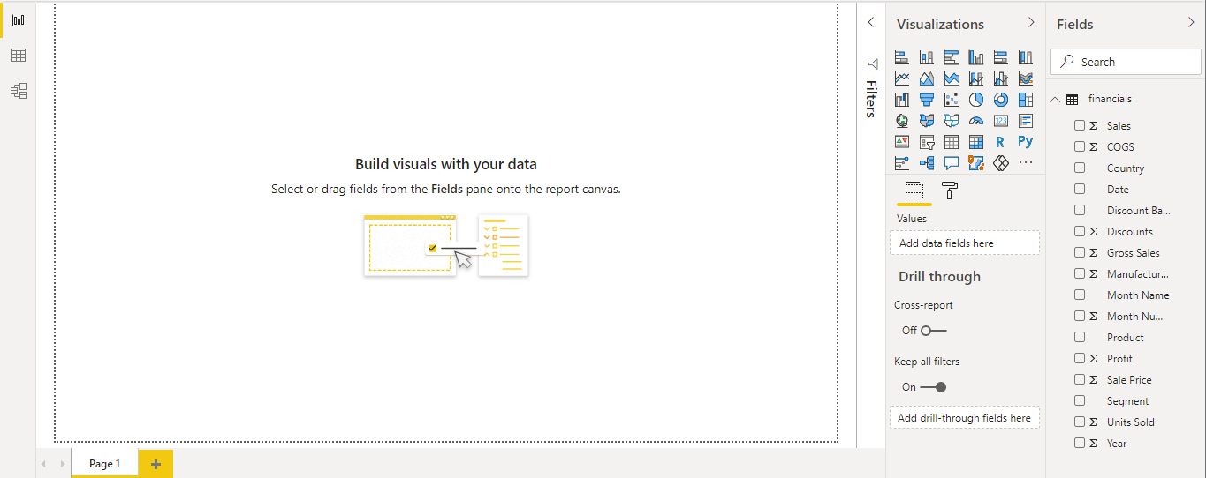

**Data View** - This view is used to view the underlying data from the source, it is a quick reference to data where we can read and validate data.

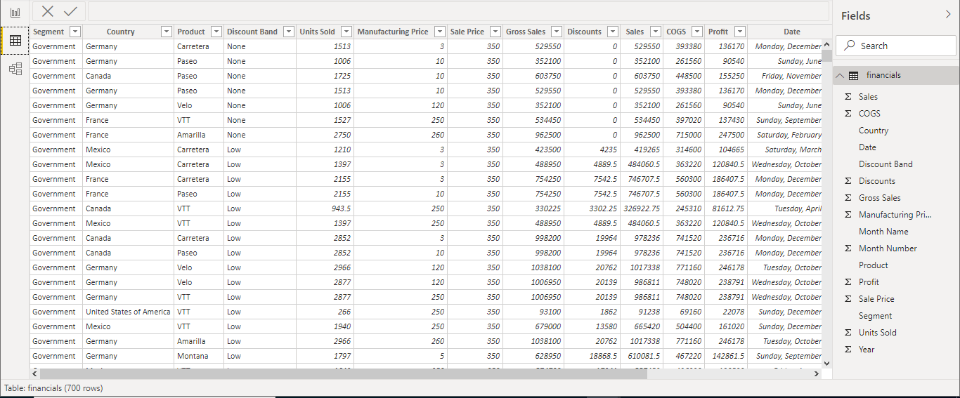

**Model View** - This view visualizes all the source schema setup and its relationship if connected to each other. A relationship is where two or more tables are linked if they are related.

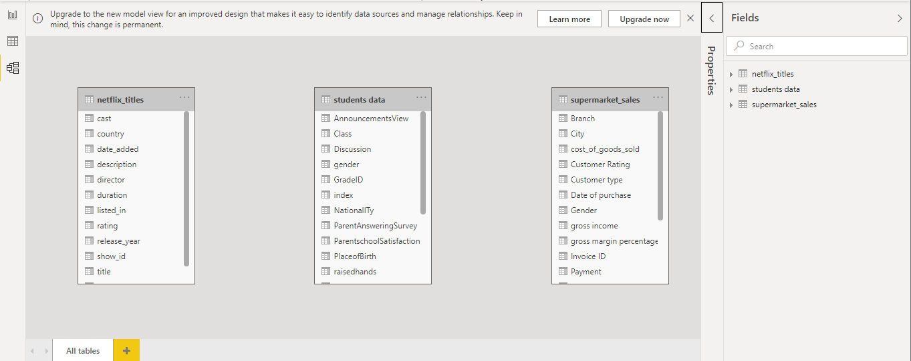

At the right side of the application there are Visualization and Fields pane (in Report View).

**Fields Pane** contains Table name and its columns from which we drag and drop to create any visual.

**Visualization Pane** contains default visuals that can be used in creating reports and options to customise axes, colors, drag additional columns.

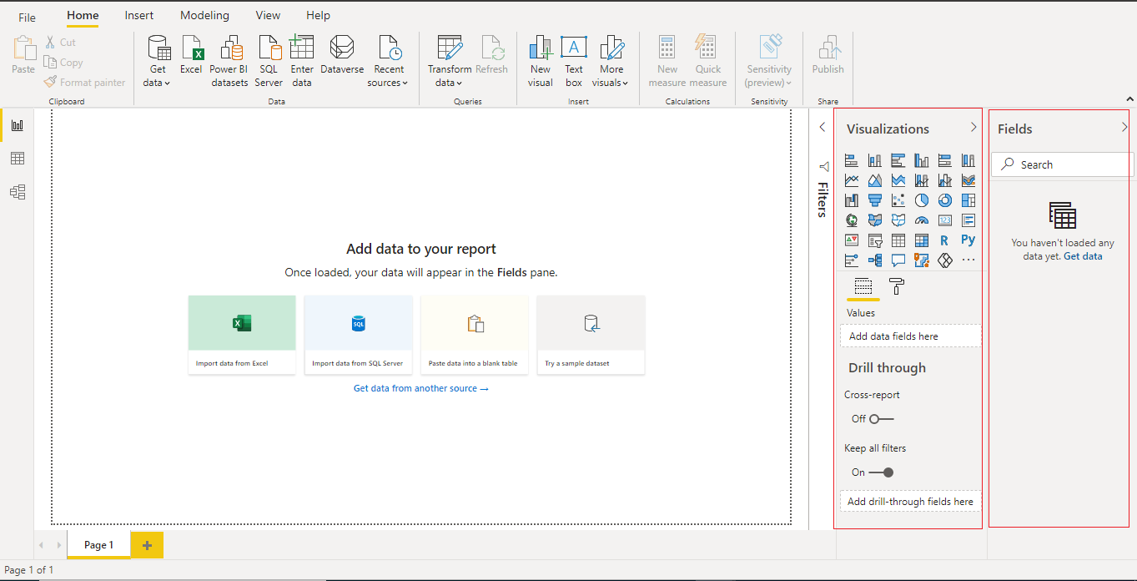

The Visualization pane contains **Fields** section to add/ drag columns to it to create visuals and **Format** section to customize and enhance visuals by color formatting, labelling etc.

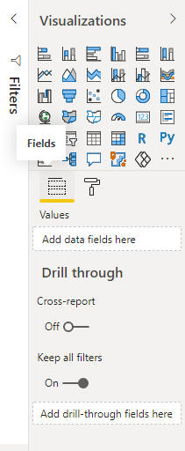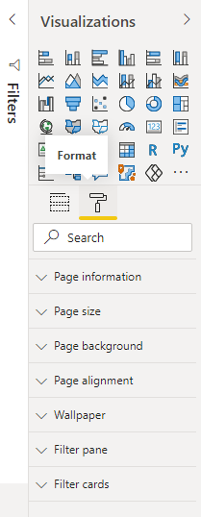

[Course](https://lms.codinginvaders.com/courses/course-v1:CodingInvaders+DATEST+1/course/) [Power BI Module 1](https://lms.codinginvaders.com/courses/course-v1:CodingInvaders+DATEST+1/course/#block-v1:CodingInvaders+DATEST+1+type@chapter+block@2c4c26b6002c466e8602380c081726e8) [Part 2 - Connecting to data sources and Creating basic charts and visuals](https://lms.codinginvaders.com/courses/course-v1:CodingInvaders+DATEST+1/course/#block-v1:CodingInvaders+DATEST+1+type@sequential+block@c630f3d5275849eca0eb325dd3185f99) Bar and column chart

## **Bar and column chart**

Bookmark this page

In this section we will learn how to create a bar/column chart using an example problem.

Bar and column charts are commonly used charts, in various fields. These charts are differentiated based on the horizontal or vertical representation of bars.

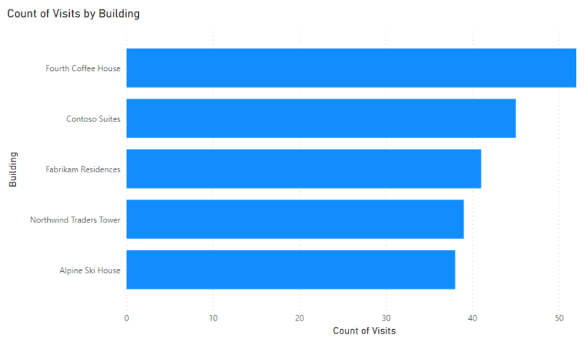

Bar Chart

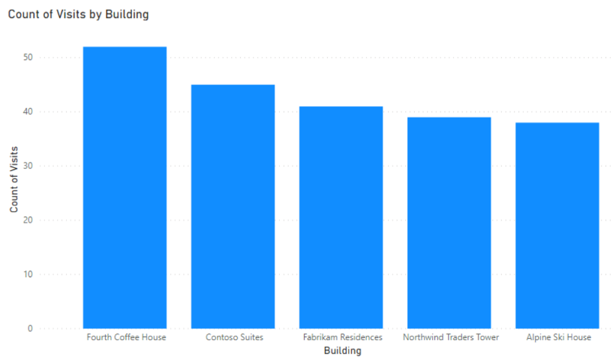

Additional Material for Bar and column chart: [**Further reading**](https://www.pluralsight.com/guides/bar-and-column-charts-in-power-bi)

**Demo Exercise:**

**Question:** A school named ABC has a dataset with students' basic and educational information. A faculty wants to know the number of students studying in each educational stage (Highschool, Middleschool,lower level).How many are studying in highschool? Create a bar/column graph to obtain the result.

**Instruction:** Create a bar chart adding Stage ID column in axis field and Index in values field (count of index is nothing but count of each student)

**Answer:** 33

**Solution:** From the given data, we can see that there are 33 students who are in Highschool.

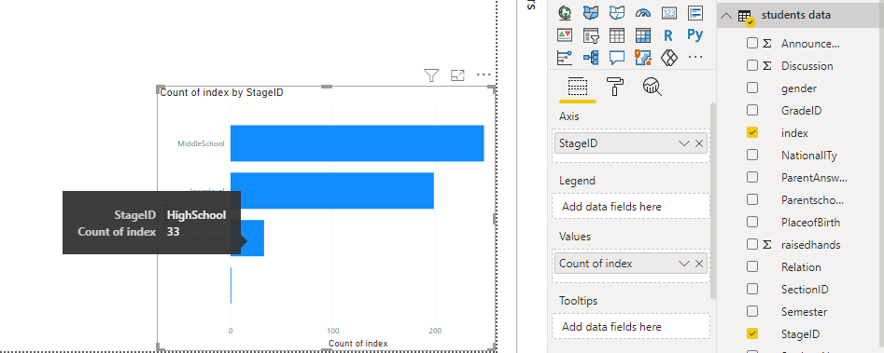

### Question 1

1 point possible (graded)

A Supermarket XYZ has entries for product sales in each branch for 3 months. One of the store supervisors from Branch ”A” wants to know how many Invoices have been generated in each branch including his own branch. How many Invoices are generated in Branch “A”?

1. Hint (1 of 1): Number of invoices generated in each branch is count of Invoice ID.  
   Axis will contain Categorical column, value field will contain Count of invoices.

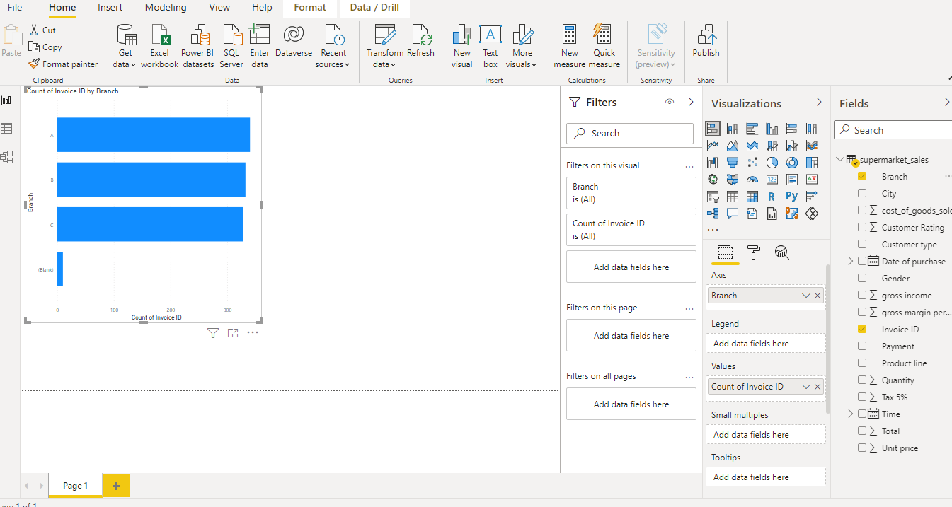

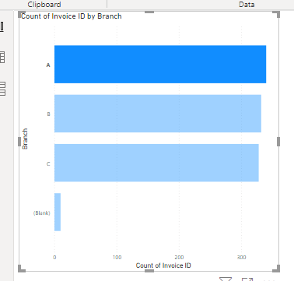

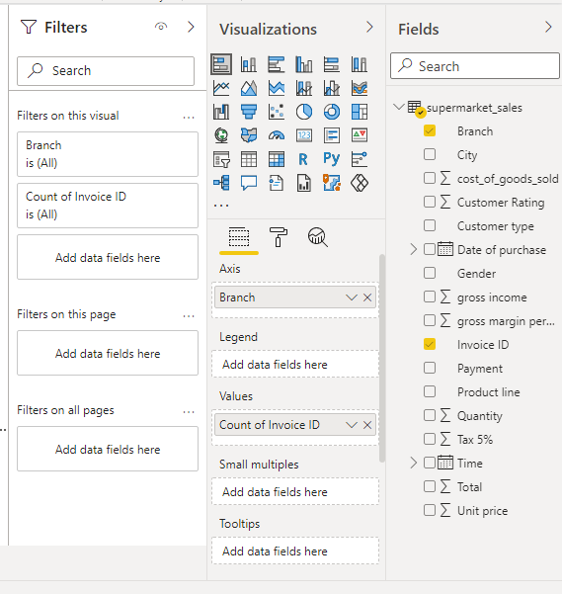

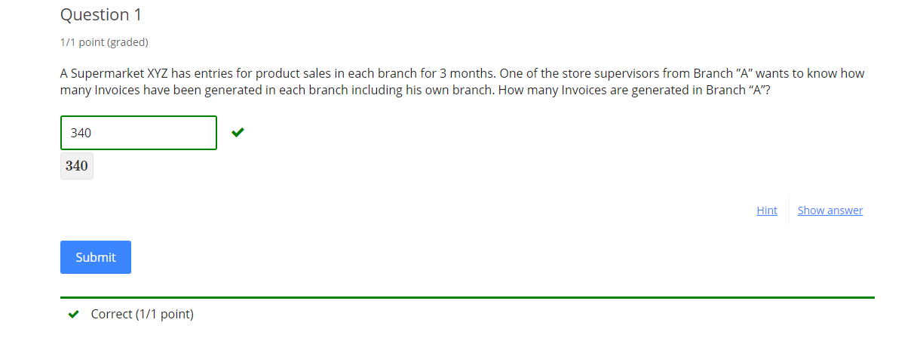

### Question 2

1 point possible (graded)

Create a Bar graph to calculate total sales by each branch. Which Branch has the highest sales?

Hint (1 of 1): Total sales is obtained from “Total” Column.

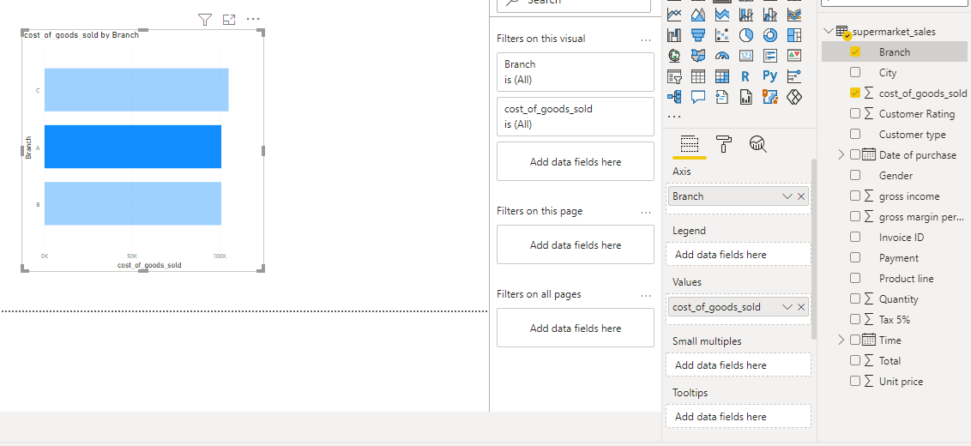

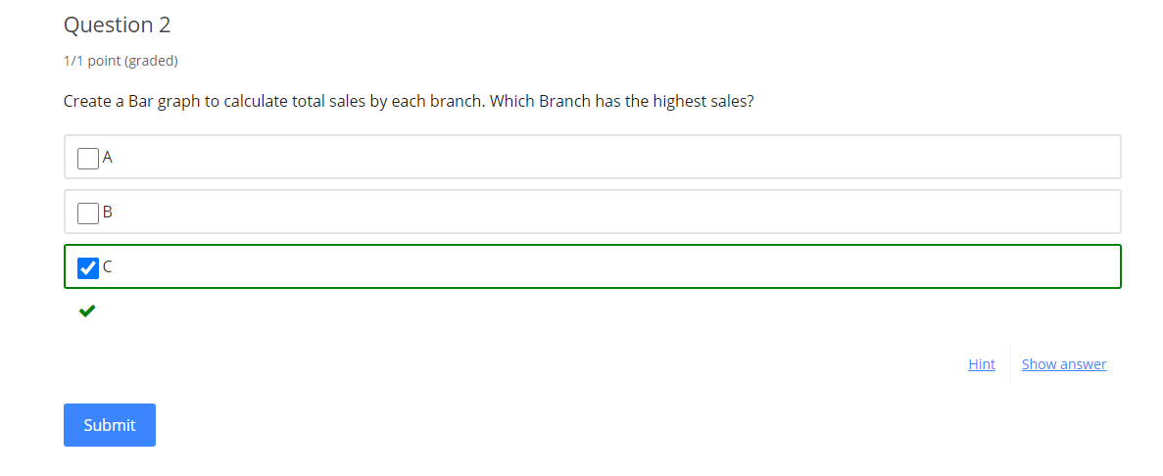

[Course](https://lms.codinginvaders.com/courses/course-v1:CodingInvaders+DATEST+1/course/) [Power BI Module 1](https://lms.codinginvaders.com/courses/course-v1:CodingInvaders+DATEST+1/course/#block-v1:CodingInvaders+DATEST+1+type@chapter+block@2c4c26b6002c466e8602380c081726e8) [Part 2 - Connecting to data sources and Creating basic charts and visuals](https://lms.codinginvaders.com/courses/course-v1:CodingInvaders+DATEST+1/course/#block-v1:CodingInvaders+DATEST+1+type@sequential+block@c630f3d5275849eca0eb325dd3185f99) Pie chart/ Donut chart

## **Pie chart/ Donut chart**

Bookmark this page

In this section we will learn how to create a Pie/ Donut chart using an example problem.

These charts are used to display distribution of a specific category and each slice or a ribbon represents each category.

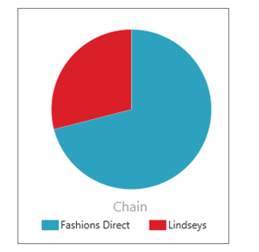

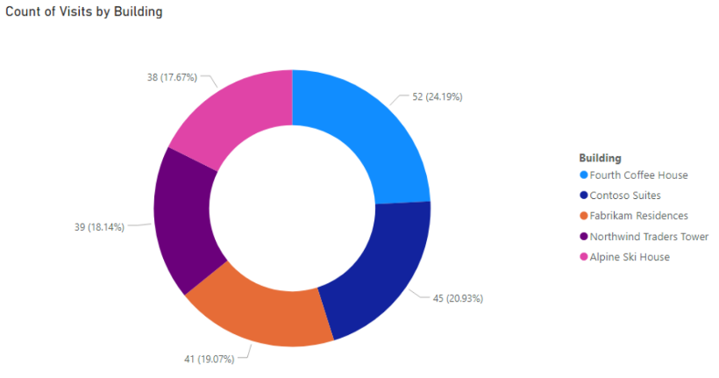

**Additional Material:**

* + [**Donut Charts**](https://docs.microsoft.com/en-us/power-bi/visuals/power-bi-visualization-doughnut-charts#:~:text=Create%20and%20use%20doughnut%20charts%20in%20Power%20BI&text=These%20visuals%20can%20be%20created,and%20the%20Power%20BI%20service.&text=A%20doughnut%20chart%20is%20similar,for%20a%20label%20or%20icon.)
  + [**Pie Chart**](https://www.goskills.com/Microsoft-Office/Resources/Power-BI-pie-chart)

**Demo Exercise:**

**Question :** From the Student database faculty wants to know the number of students that are absent for more than 7 days. Create a pie/Donut chart to obtain distribution of absentees more than 7 days.

**Instruction:** Create a pie chart adding Student absent days column in legend field and Index in values field (count of index is nothing but count of each student)

**Answer:** 191

**Solution:** From the given data, we can see that there are 191 students who are absent for more than 7 days.

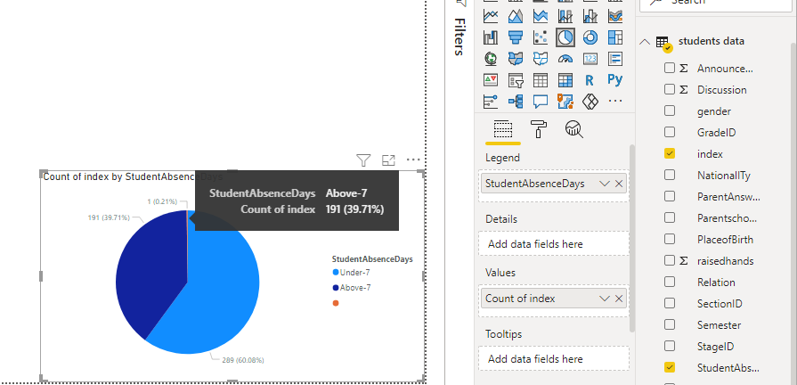

### Question 1

1 point possible (graded)

Store owner wants to know how many customers have membership and how many do not have any membership. Create a Donut chart to show the number of customers that are a member of that store.

1. Hint (1 of 1): Number of customers is obtained from invoices generated.  
   Type of membership is Normal or Member.  
   Legend will contain a Categorical column.

### Question 2

1 point possible (graded)

Create a Pie chart to calculate total sales by each type of payment made. Which payment type is having the highest sales?

1. Hint (1 of 1): Payment type - Ewallet, Cash, Card

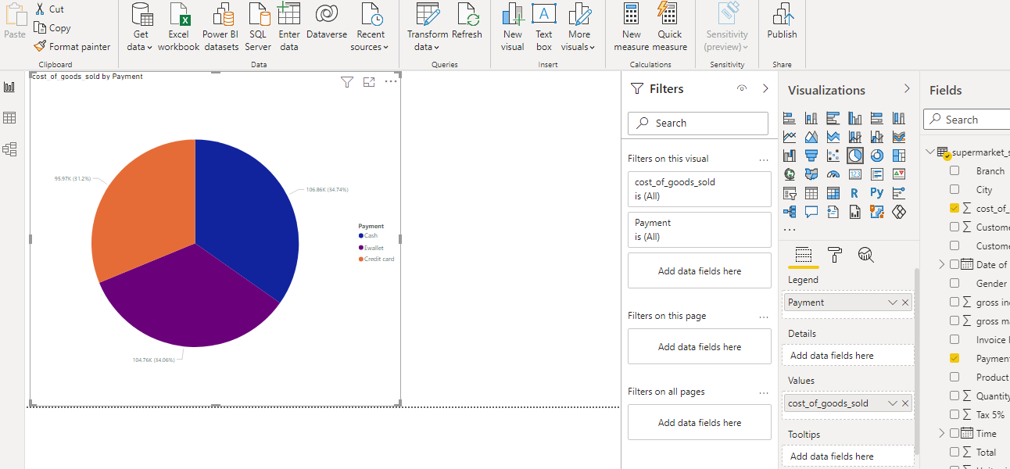

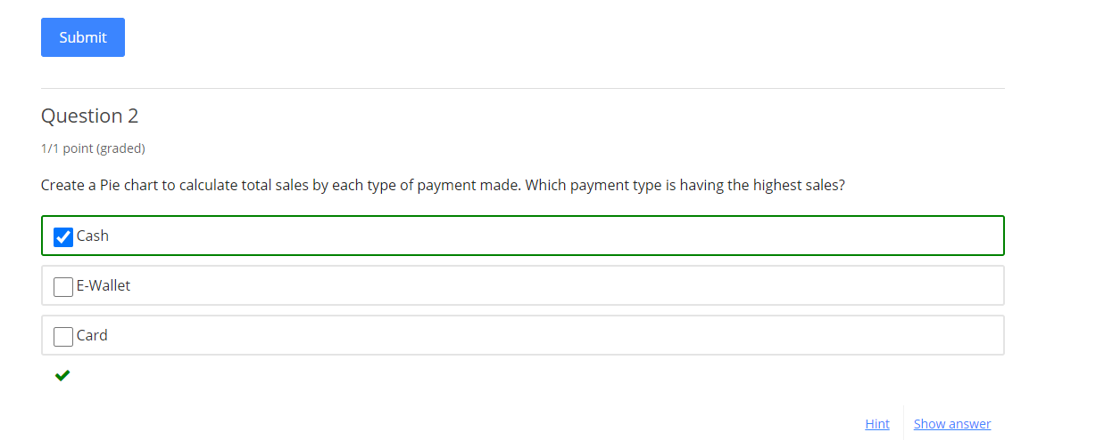

[Course](https://lms.codinginvaders.com/courses/course-v1:CodingInvaders+DATEST+1/course/) [Power BI Module 1](https://lms.codinginvaders.com/courses/course-v1:CodingInvaders+DATEST+1/course/#block-v1:CodingInvaders+DATEST+1+type@chapter+block@2c4c26b6002c466e8602380c081726e8) [Part 2 - Connecting to data sources and Creating basic charts and visuals](https://lms.codinginvaders.com/courses/course-v1:CodingInvaders+DATEST+1/course/#block-v1:CodingInvaders+DATEST+1+type@sequential+block@c630f3d5275849eca0eb325dd3185f99) Clustered and stacked chart

## **Clustered and stacked chart**

Bookmark this page

In this section we will learn how to create a Clustered/ stacked chart using an example problem. These charts are useful to compare multiple dimensions or columns against a single measure or a table column.

**Clustered Charts** - Clustered Bar and Clustered column chart

**Stacked Charts** - Stacked Bar and Stacked Column Chart

In Clustered Charts, multiple bars are grouped based on the categories of columns. Bar and column clusters are similar in functionalities except for the visual representation.

In Stacked charts, categories are stacked in a bar one above the other. Bar and column stacks are similar except for visual representation.

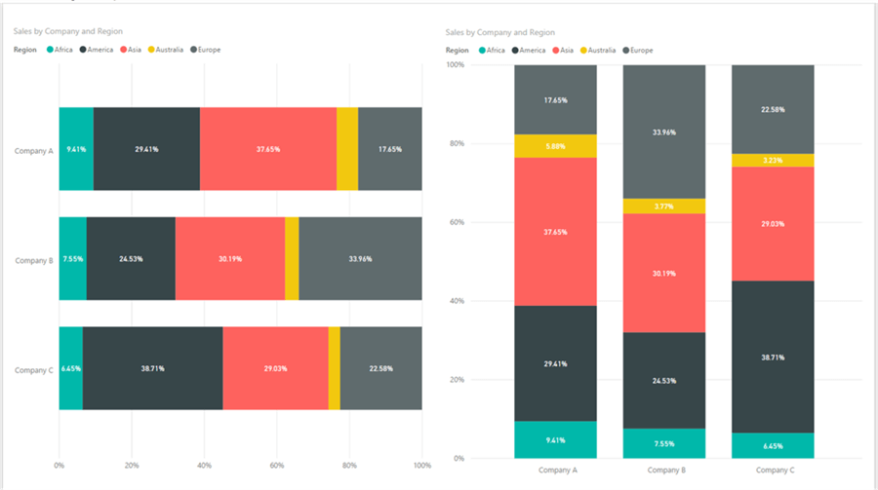

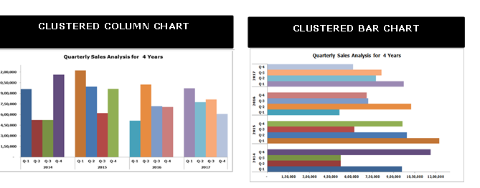

**Additional material:**

* + [**Clustered Chart**](https://www.tutorialgateway.org/clustered-column-chart-in-power-bi/)
  + [**Stacked Chart**](https://www.tutorialgateway.org/power-bi-stacked-bar-chart/)

**Demo Exercise:**

**Question :** A faculty wants to know the number of students studying in each educational stage (Highschool, Middleschool,lower level) and in addition to it he wants to find out how many male/ female students are present in each category. Create a Clustered/ Stacked column chart to obtain the number of Female students.

**Instructions:** Create a Clustered chart adding Student stage ID column in Axis field, Gender column in legend field and Index in values field (count of index is nothing but count of each student)

**Answer:** 15

**Solution :** Axis Field - Stage ID

Legend Field - Gender

Values Field - Count of Index

From the given data, we can see that there are 15 Female students studying in High School.

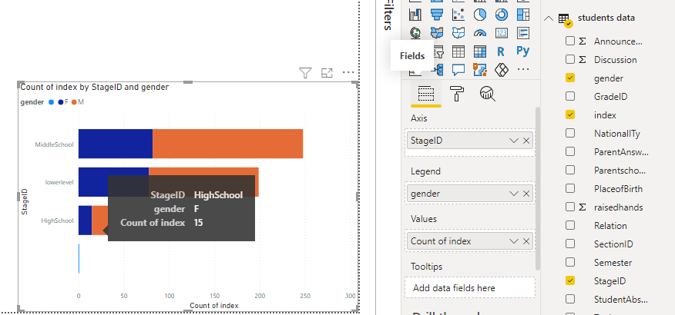

### Question 1

1 point possible (graded)

Store owner wants to know how many invoices have been settled through cash/ card/ e-wallet and how many male/ female have made these payment types.Create a stacked column chart to show the stats of the number of female customers who have paid through e-wallet.

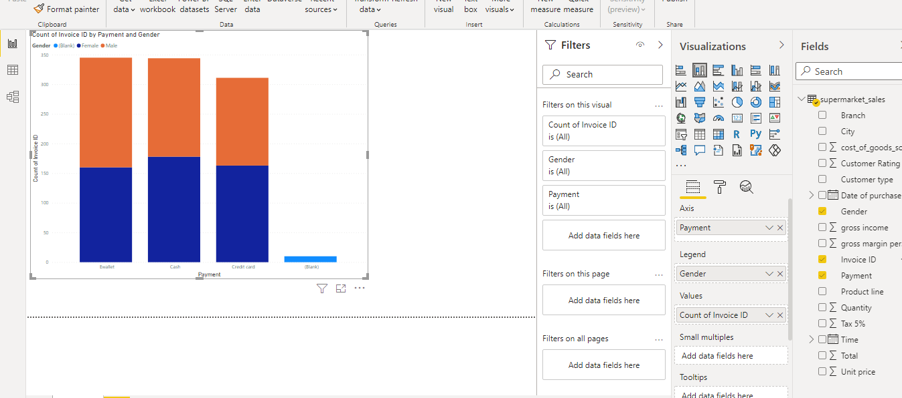

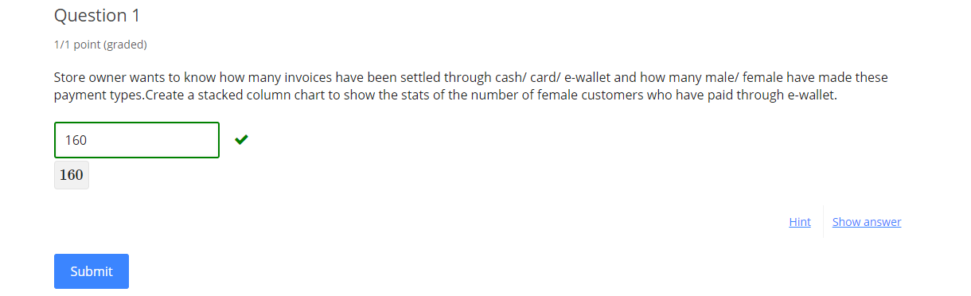

1. Hint (1 of 1): Number of customers is obtained from invoices generated.  
   Type of payment cash/ card/ e-wallet.  
   Add “gender” column to legend field

Next Hint

Review

Hint

Submit

Some problems have options such as save, reset, hints, or show answer. These options follow the Submit button.

### Question 2

1 point possible (graded)

Create a Clustered Chart to calculate number of sales each month made by male and female . How many products were sold in the month of March to Male buyers?

1. Hint (1 of 1): Month can be dragged from Date of purchase column hierarchy.  
   Type of payment cash/ card/ e-wallet.  
   Add “gender” column to legend field

Next Hint

Review

Hint

Submit

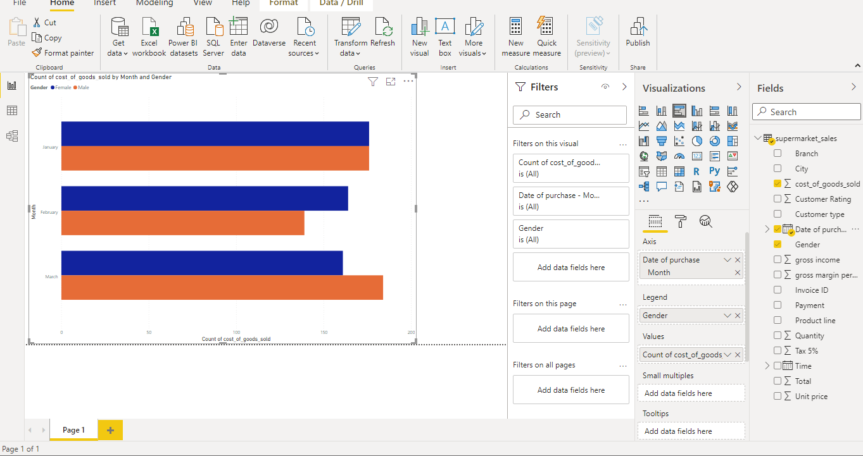

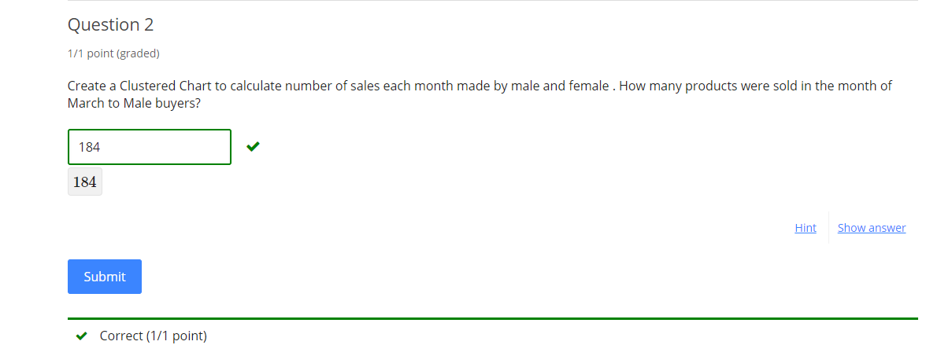

[Course](https://lms.codinginvaders.com/courses/course-v1:CodingInvaders+DATEST+1/course/) [Power BI Module 1](https://lms.codinginvaders.com/courses/course-v1:CodingInvaders+DATEST+1/course/#block-v1:CodingInvaders+DATEST+1+type@chapter+block@2c4c26b6002c466e8602380c081726e8) [Part 2 - Connecting to data sources and Creating basic charts and visuals](https://lms.codinginvaders.com/courses/course-v1:CodingInvaders+DATEST+1/course/#block-v1:CodingInvaders+DATEST+1+type@sequential+block@c630f3d5275849eca0eb325dd3185f99) Line / Area chart

## **Line / Area chart**

Bookmark this page

In this section we will learn how to create Line and Area charts using an example problem.

Line chart is a graph that displays data with a point and these points connected by a line. Area charts are similar to this with the shaded portion below the line.

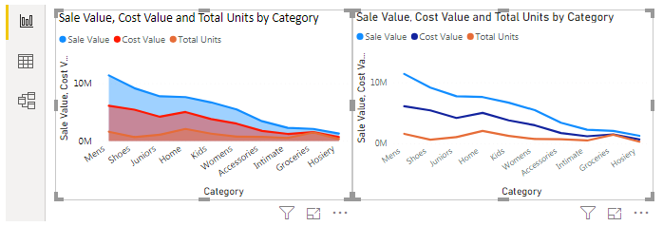

**Additional material :**

* + [**Line chart**](https://docs.microsoft.com/en-us/power-bi/visuals/power-bi-line-chart)
  + [**Area chart**](https://docs.microsoft.com/en-us/power-bi/visuals/power-bi-visualization-basic-area-chart)

**Demo Exercise:**

**Question 1 :** A faculty wants to know the average number of resources that are visited by students from each grade. Create an Area/ line chart chart to obtain this.What is the average of resources visited by 8th Grade(G-08)?

Sort the axis in an ascending order of grade level.

**Instructions:** To sort, select the line/ area chart created > click on more options > sort ascending > sort by Grade ID

**Answer:** 62.29

**Solution :** Create a Line / Area chart adding Grade ID column in Axis field, Visited Resources column in values field.

From the given data, G-08 students have visited 62.29 resources on an average.

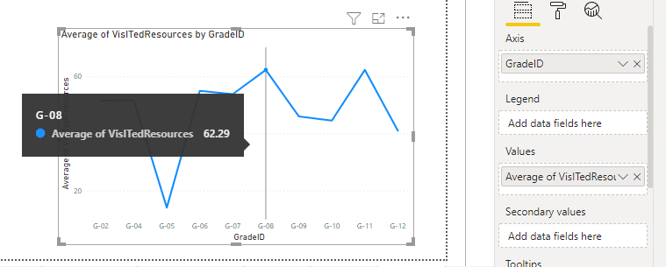

**Question 2:** Find the maximum number of students who raised hands and maximum number of students who took part in discussion in each section. Create a Line/ Area chart and obtain the maximum number of raised hands in Section B.

**Instruction:** create Multi line chart , Drag 2 fields to value field to create multi lie chart

**Answer:** 100

**Solution:** Axis -Section ID

Value field - Max of Raised hands, Max of Discussion

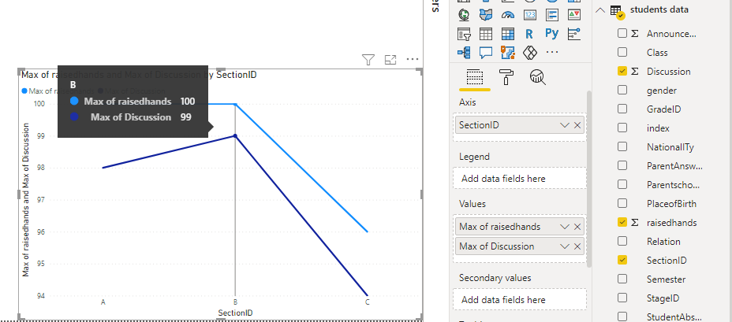

### Question 1

1 point possible (graded)

Store owners want to calculate the average gross income each month.Create an Area Chart to find out What is the highest average of gross income?

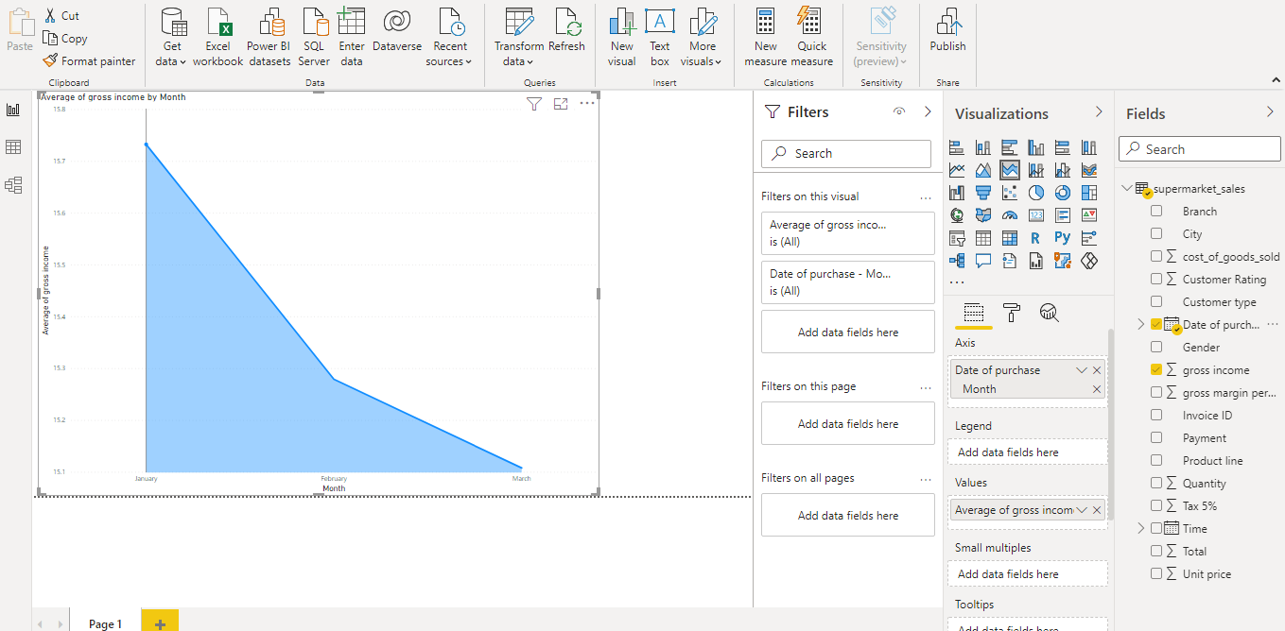

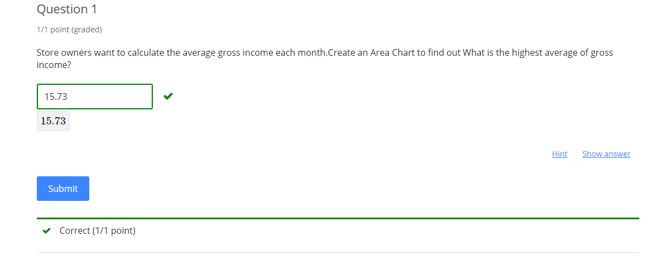

1. Hint (1 of 1): For month field drop down “date of purchase” column hierarchy

Next Hint

Review

Hint

Submit

Some problems have options such as save, reset, hints, or show answer. These options follow the Submit button.

### Question 2

1 point possible (graded)

Create a Line Chart to Compare Average of Cost of goods sold and average total sales by month. What is the Average of Cost of goods sold in the month of march?

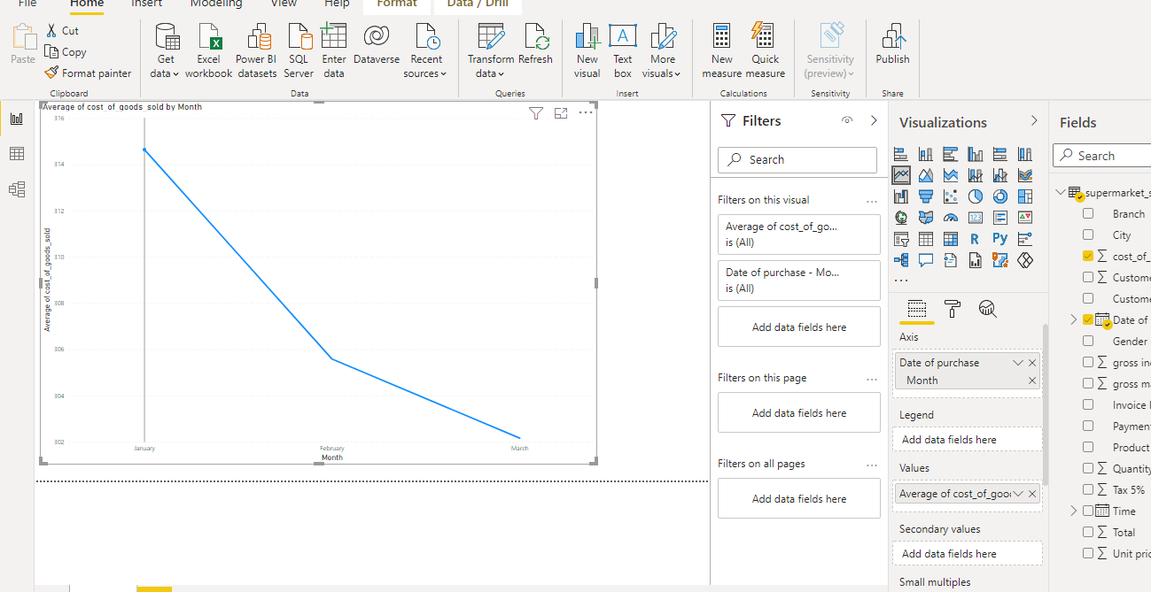

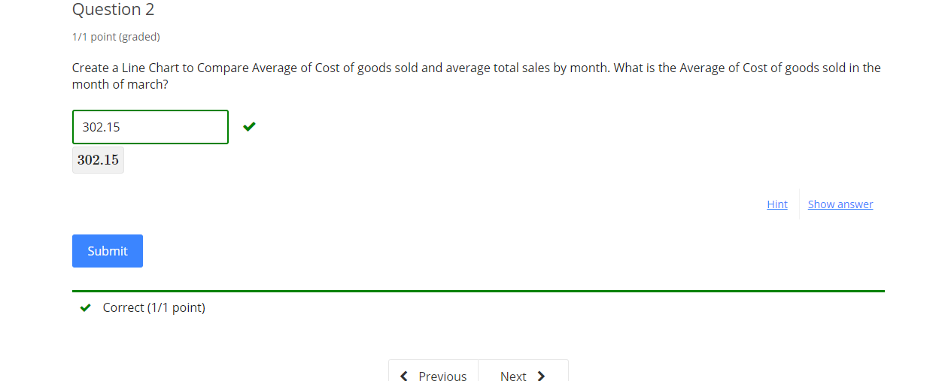

1. Hint (1 of 1): Month can be dragged from Date of purchase column dropdown This is a Multi line chart, Number of columns dragged to the value field corresponds to the number of lines in the chart.

Next Hint

Review

Hint

Submit

## [**Course**](https://lms.codinginvaders.com/courses/course-v1:CodingInvaders+DATEST+1/course/)[**Power BI Module 1**](https://lms.codinginvaders.com/courses/course-v1:CodingInvaders+DATEST+1/course/#block-v1:CodingInvaders+DATEST+1+type@chapter+block@2c4c26b6002c466e8602380c081726e8)[**Part 2 - Connecting to data sources and Creating basic charts and visuals**](https://lms.codinginvaders.com/courses/course-v1:CodingInvaders+DATEST+1/course/#block-v1:CodingInvaders+DATEST+1+type@sequential+block@c630f3d5275849eca0eb325dd3185f99) **Slicers - variations like list, dropdown, horizontal, range**

## **Slicers - variations like list, dropdown, horizontal, range**

Bookmark this page

Slicers are simple filters that can be used directly on report to filters/ select data based on specific categories, date and time. Slicers are used to filter data from visuals all at once. Columns like categorical, date or numerical are suitable for this type.

To create a slicer we need to select a slicer visual from charts and drag and drop columns of our choice.

There are 2 variations in slicers - Horizontal, vertical slicers.

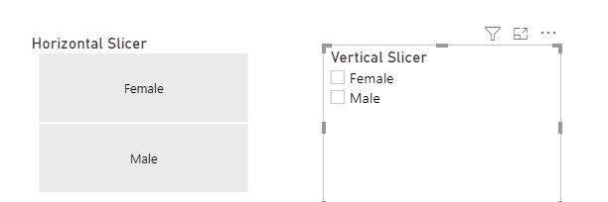

Vertical slicers can be a list or dropdown , Numerical / Date slicers can be additionally set up like a sliding range.

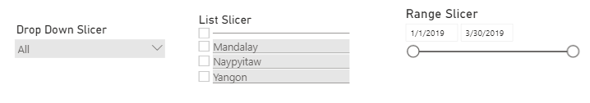

Additional Material for slicers : [**Further Reading**](https://docs.microsoft.com/en-us/power-bi/visuals/power-bi-visualization-slicers)

**Demo Exercise:**

**Question :** A faculty wants to know the number of students studying in each educational stage (Highschool, Middleschool,lower level) also, wants to filter based on different topics being taught. Add a slicer for topics and obtain a number for students studying Arabic in Lower level. (Create a dropdown slicer).

**Instructions:** Create a Bar/ column chart adding Student stage ID column in Axis field, Index in values field (count of index is nothing but count of each student) .

**Answer:** 31

**Solution:** Add a slicer visual and drag Topic column to field. Select Arabic as a topic from slicer and observe the count of students in Lower level stage.

From the given data, we can see that there are 31 students studying Arabic in Lower Level.

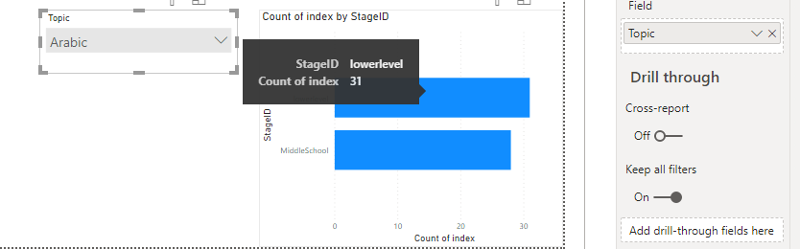

### Question 1

1 point possible (graded)

Store owner wants to know how many invoices have been generated in Branch “B” from February 1st,2019 onwards. Create a bar chart and a slicer to show the number of invoices generated in Branch B.

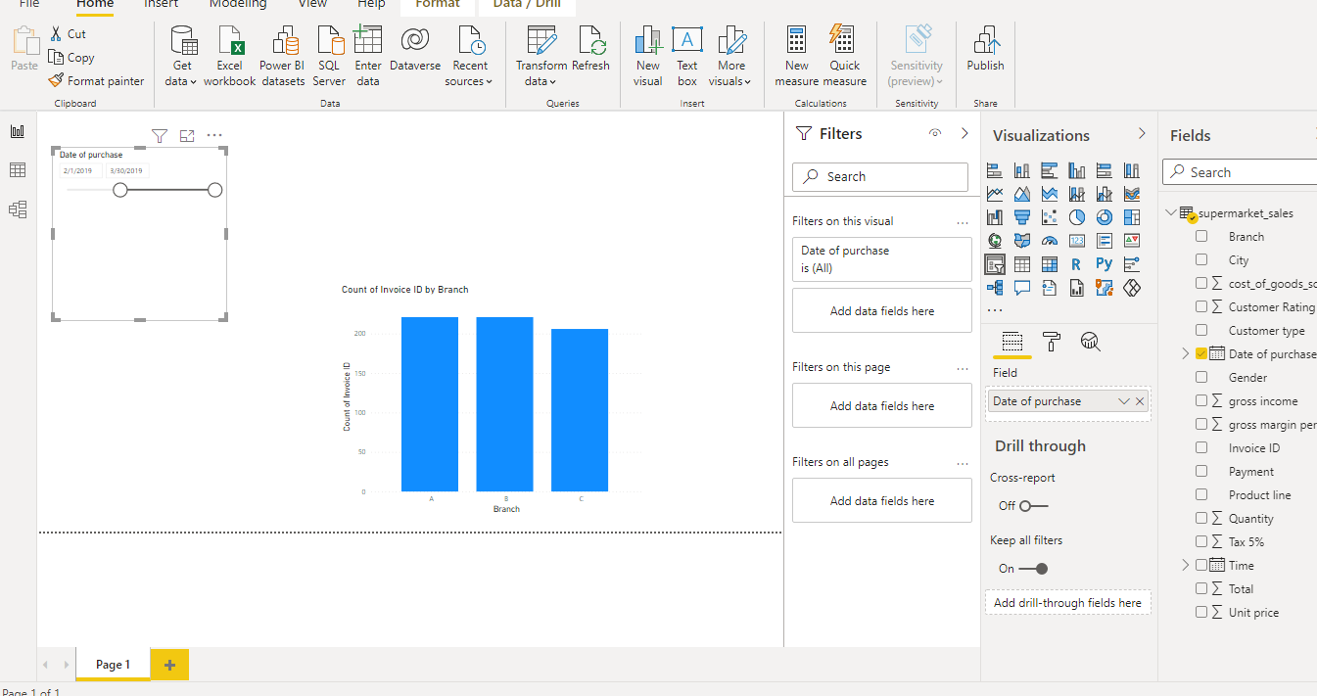

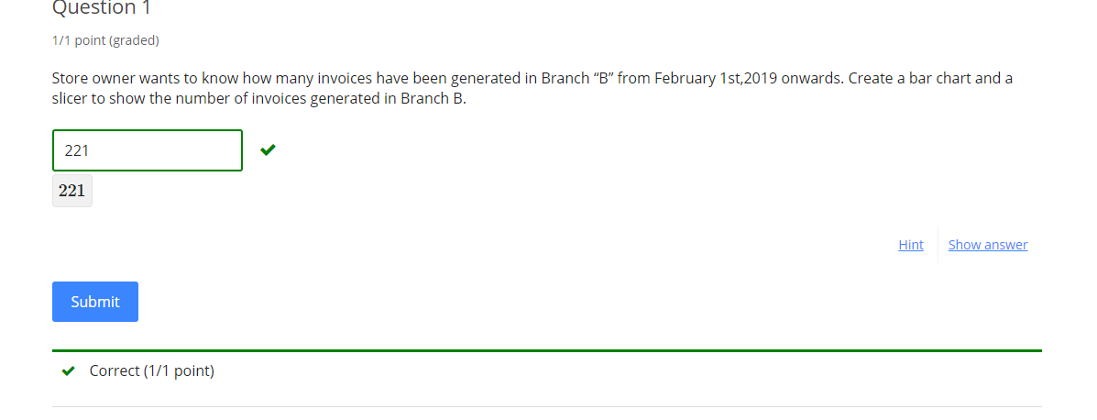

Hint

Submit

Some problems have options such as save, reset, hints, or show answer. These options follow the Submit button.

### Question 2

1 point possible (graded)

Store owner wants to know how many invoices have been generated in Branch “B” between January 15th and February 15th . Show the number of invoices generated using a bar chart and a range slicer.

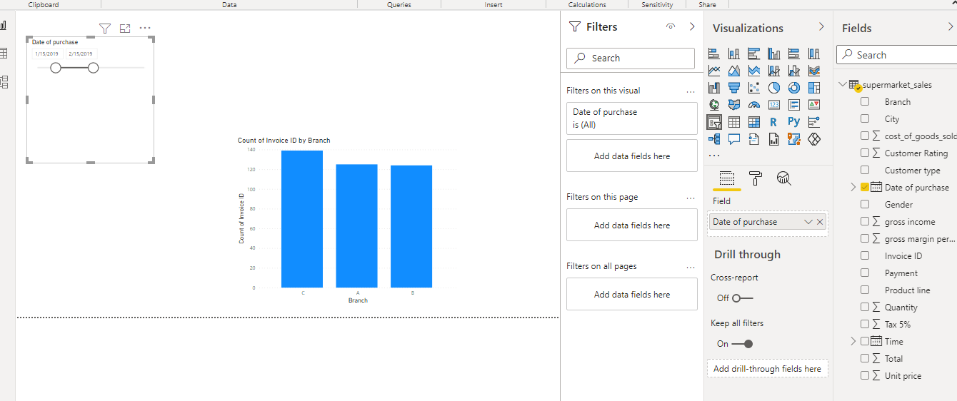

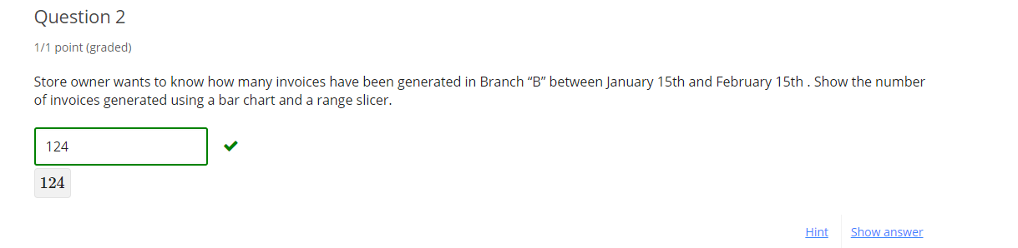

Hint

Submit

Some problems have options such as save, reset, hints, or show answer. These options follow the Submit button.

### Question 3

1 point possible (graded)

Store owner wants to know how many invoices have been generated at Branch “B” for Home and lifestyle products. Show the number of invoices generated using a List slicer.

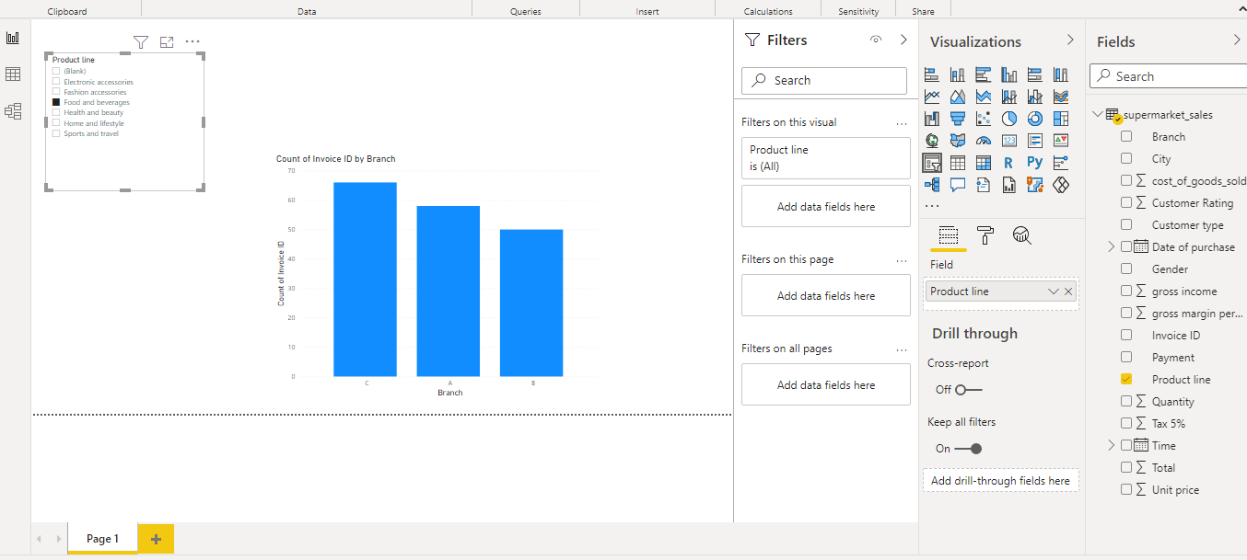

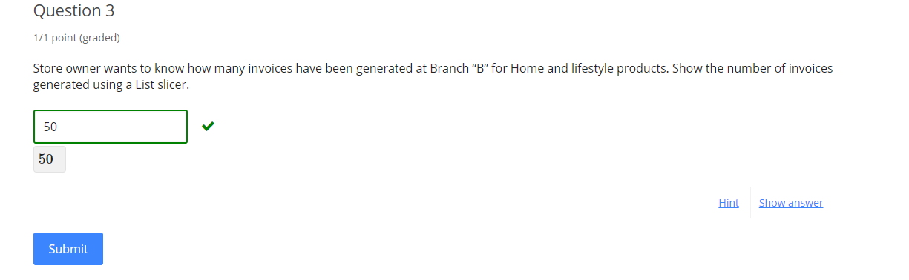

Hint

Submit

Some problems have options such as save, reset, hints, or show answer. These options follow the Submit button.

### Question 4

1 point possible (graded)

Store owner wants to know how many invoices have been generated in Branch “B” filter for Male customers only. Show the number of invoices generated using a Horizontal slicer.

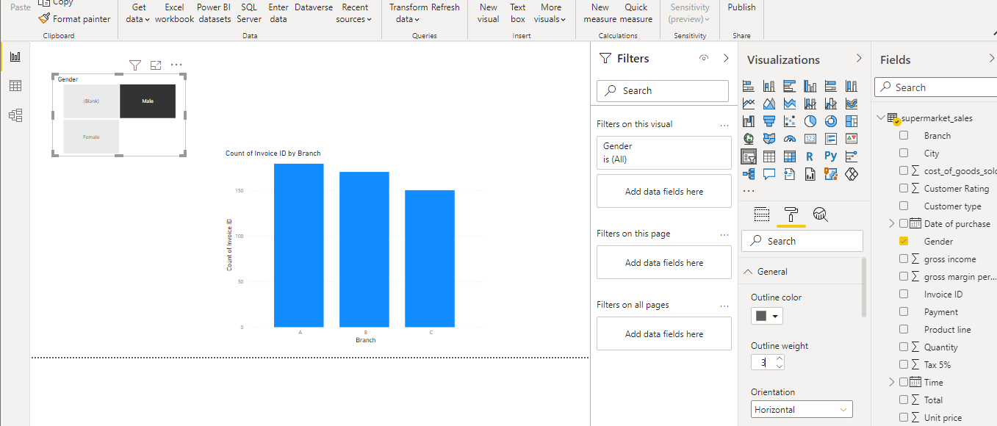

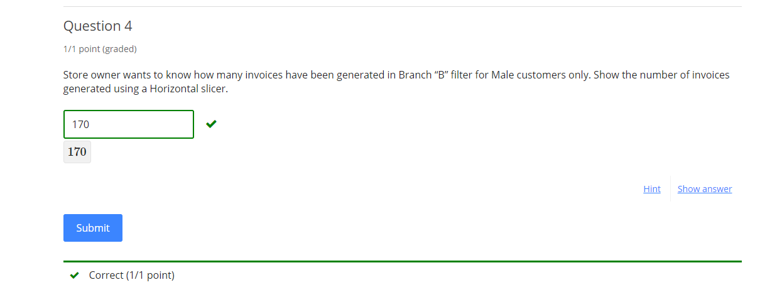

Submit

Some problems have options such as save, reset, hints, or show answer. These options follow the Submit button.

## [**Course**](https://lms.codinginvaders.com/courses/course-v1:CodingInvaders+DATEST+1/course/)[**Power BI Module 1**](https://lms.codinginvaders.com/courses/course-v1:CodingInvaders+DATEST+1/course/#block-v1:CodingInvaders+DATEST+1+type@chapter+block@2c4c26b6002c466e8602380c081726e8)[**Part 3 - Cleansing data with Query Editor**](https://lms.codinginvaders.com/courses/course-v1:CodingInvaders+DATEST+1/course/#block-v1:CodingInvaders+DATEST+1+type@sequential+block@dc055326dcb945f0bf907d213e3e613e) **Filtering**

## 

## **Filtering**

Bookmark this page

Power Query Editor is a tool which is used to Cleanse and Transform data from impurities and to check if data is in the right format.

To launch Query Editor, click on Home tab > Click on Transform Data icon

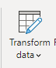

A new window will be opened, refer screenshot below.

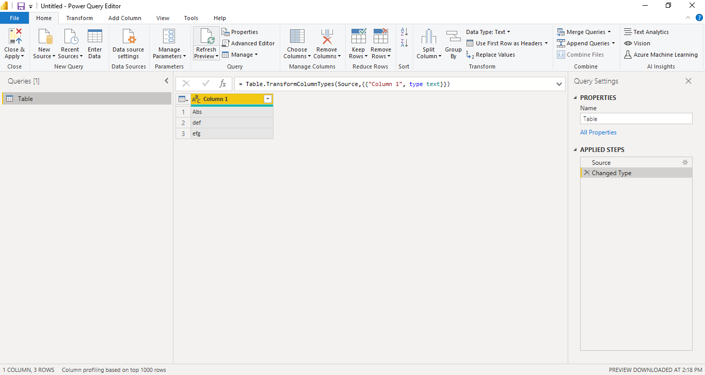

This tool will have various options that help in cleaning data and transforming data to make it ready to be consumed by the report. All changes made here will only be reflected in Reports generated and the underlying source table will not be modified.

To apply changes made using this tool, click on Home tab >click on Close and Apply



In case the changes are not required to be saved, Click on Home tab > dropdown and select “Close” . This will discard the changes.

**Filtering**

This is a similar feature that is used in Excel sheets. It filters data based on user requirement.

Additional Material : [**Filtering Data**](https://www.iscorp.biz/power-bi-filtering-your-data/#:~:text=To%20filter%20the%20query%20access,that%20you%20can%20choose%20from.)

**Demo Exercise:**

**Question:** Filter out only “IT” topics from Students’ data table and count the number of rows present.

Note: To count rows click on transform tab> click on count rows icon

To Undo delete the last applied step , Refer the screenshot with highlighted fields (Applied steps and Count Rows)

Count of rows will be displayed, undo this step to go back to data.

To undo, delete the last applied step named “Counted rows” , further if you want to remove this filter applied delete the applied step named “Filtered Rows” ( This will go back to original unfiltered data)

**Answer:** 95

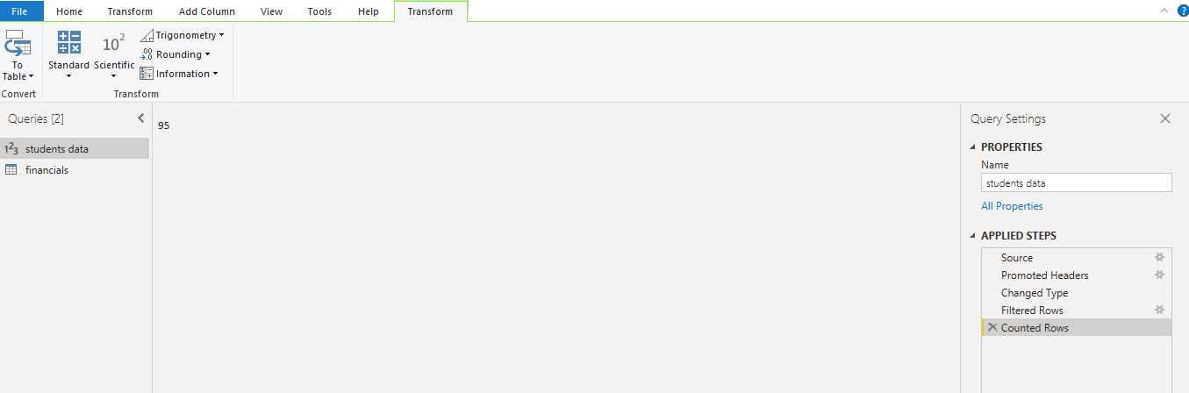

Note: Undo filtering steps after completing the exercise in Guided dataset.

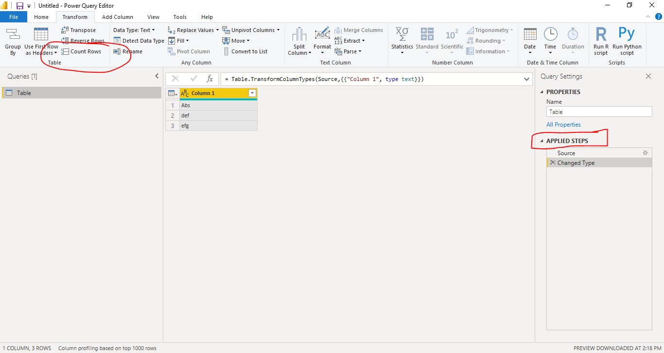

### Question 1

1 point possible (graded)

Filter the number of products with Unit price greater than 50.

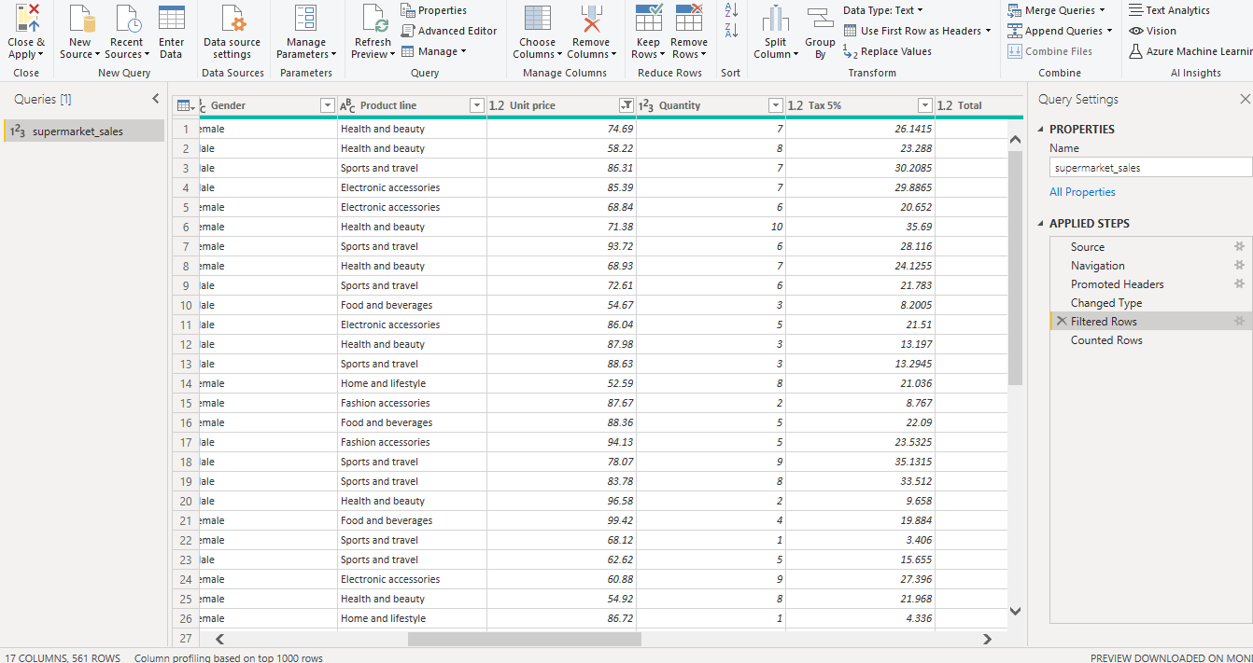

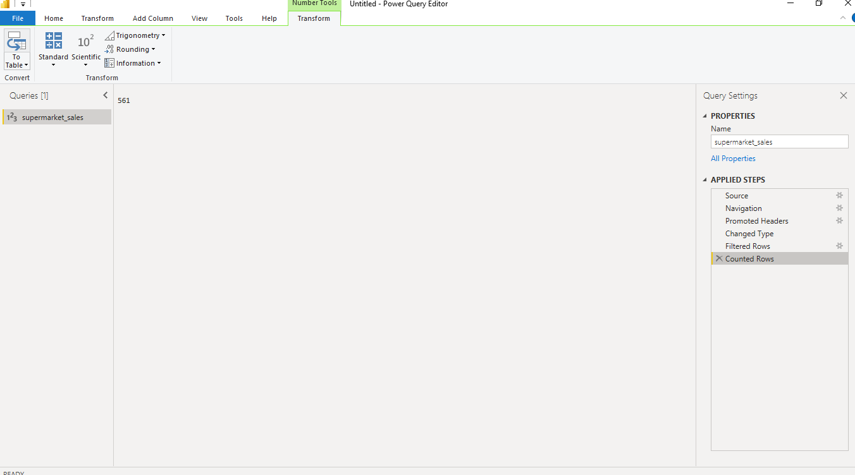

1. Hint (1 of 1): Apply number filters greater than 50  
   Count rows and obtain the result

Next Hint

Review

Hint

Submit

Some problems have options such as save, reset, hints, or show answer. These options follow the Submit button.

[Course](https://lms.codinginvaders.com/courses/course-v1:CodingInvaders+DATEST+1/course/) [Power BI Module 1](https://lms.codinginvaders.com/courses/course-v1:CodingInvaders+DATEST+1/course/#block-v1:CodingInvaders+DATEST+1+type@chapter+block@2c4c26b6002c466e8602380c081726e8) [Part 3 - Cleansing data with Query Editor](https://lms.codinginvaders.com/courses/course-v1:CodingInvaders+DATEST+1/course/#block-v1:CodingInvaders+DATEST+1+type@sequential+block@dc055326dcb945f0bf907d213e3e613e) Duplicate removal

## **Duplicate removal**

Bookmark this page

Duplicated entry in the table can be due to manual error or because of repeated operations to a table. It is necessary to remove these rows so as to avoid misinterpretation of data.

To remove duplicate values,Select columns where duplicates has to be removed> click on Home tab> Drop Down remove rows > Click on Remove duplicate rows

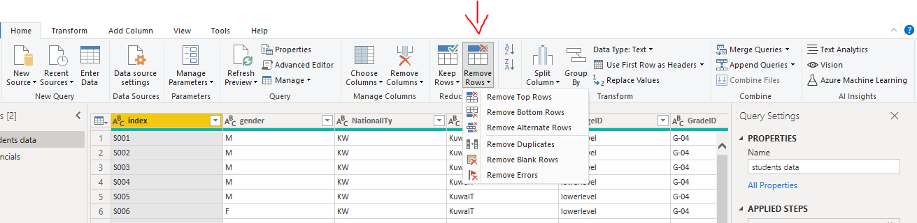

Additional Material: [**Removing Duplicates**](https://www.seerinteractive.com/blog/pbi-cleaning-tips/)

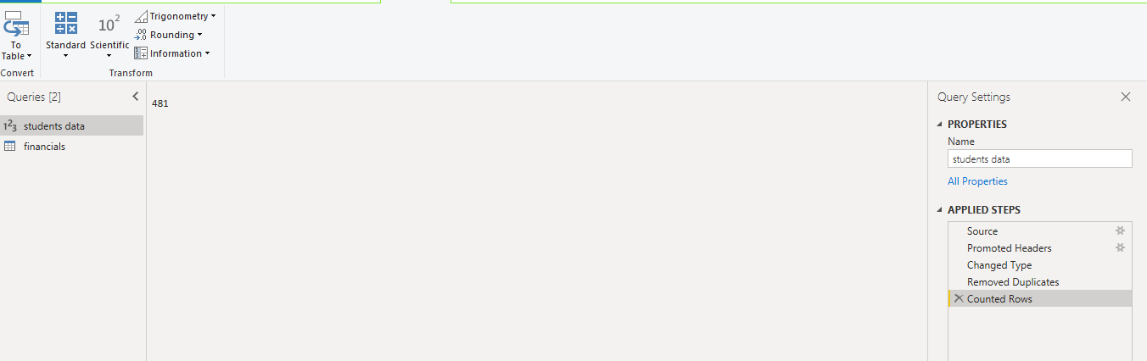

**Demo exercise:**

**Question:** Remove Duplicate from Index Column and count the number of rows present after removal.

**Answer:** 481

**Solution :** After removing duplicates there are 481 Rows present in the table.

**Note:** Undo these changes to go back to data, i.e delete Counted rows step from applied steps.

### Question 1

1 point possible (graded)

Remove the duplicates present in Supermarket data and obtain the row count.

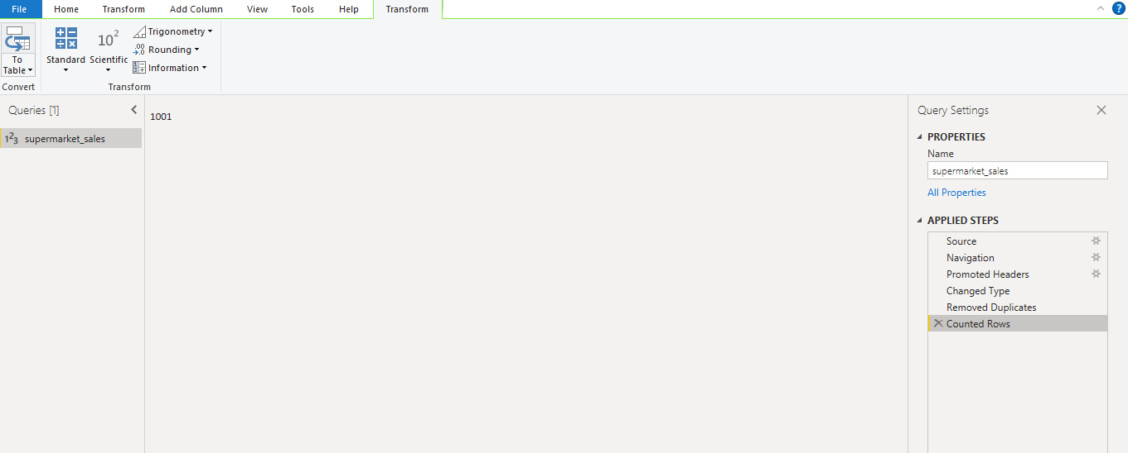

Hint

Submit

Some problems have options such as save, reset, hints, or show answer. These options follow the Submit button.

[Course](https://lms.codinginvaders.com/courses/course-v1:CodingInvaders+DATEST+1/course/) [Power BI Module 1](https://lms.codinginvaders.com/courses/course-v1:CodingInvaders+DATEST+1/course/#block-v1:CodingInvaders+DATEST+1+type@chapter+block@2c4c26b6002c466e8602380c081726e8) [Part 3 - Cleansing data with Query Editor](https://lms.codinginvaders.com/courses/course-v1:CodingInvaders+DATEST+1/course/#block-v1:CodingInvaders+DATEST+1+type@sequential+block@dc055326dcb945f0bf907d213e3e613e) Remove nulls or errors

## **Remove nulls or errors**

Bookmark this page

When rows of an entire table are blank or Null it is called blank row.

To remove blank rows from table ,click on Home tab> Drop Down remove rows > Click on Remove blank rows



To remove Error from table ,Select columns where errors are present> click on Home tab> Drop Down remove rows > Click on Remove Errors

Note: If a column has errors then this will throw an exception while loading data at the initial stage to load without errors.

Additional Material : [**Remove Blanks or Errors**](https://www.exceljetconsult.com.ng/home/blog/delete-blank-rows-in-power-bi-and-excel/)

**Demo exercise:**

Question: Remove blank rows from the students data table and count the number of rows present after removal.(Perform this as next step, after removing duplicates)

Answer: 480

Solution: After removing blanks there are 480 Rows present in the table.

Note: Undo these changes to go back to data, i.e delete Counted rows step from applied steps.

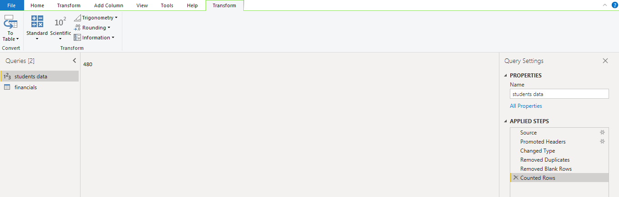

### Question 1

1 point possible (graded)

Remove blank rows present in Supermarket data and obtain the row count.

(only applying step to Remove blank rows)

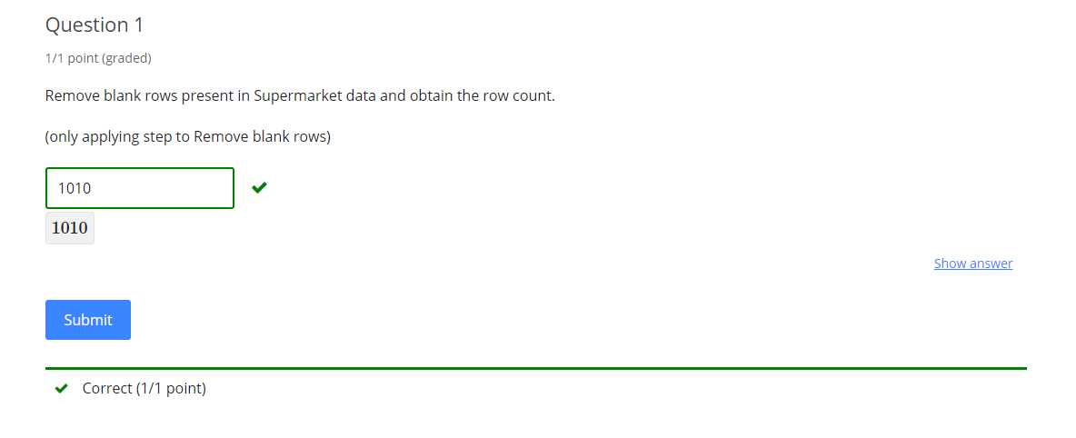

Submit

[Course](https://lms.codinginvaders.com/courses/course-v1:CodingInvaders+DATEST+1/course/) [Power BI Module 1](https://lms.codinginvaders.com/courses/course-v1:CodingInvaders+DATEST+1/course/#block-v1:CodingInvaders+DATEST+1+type@chapter+block@2c4c26b6002c466e8602380c081726e8) [Part 3 - Cleansing data with Query Editor](https://lms.codinginvaders.com/courses/course-v1:CodingInvaders+DATEST+1/course/#block-v1:CodingInvaders+DATEST+1+type@sequential+block@dc055326dcb945f0bf907d213e3e613e) Replacing Values

## **Replacing Values**

Bookmark this page

To replace data values from any column ,Select desired column > click on Transform tab> Drop Down Replace values > Click on Replace values

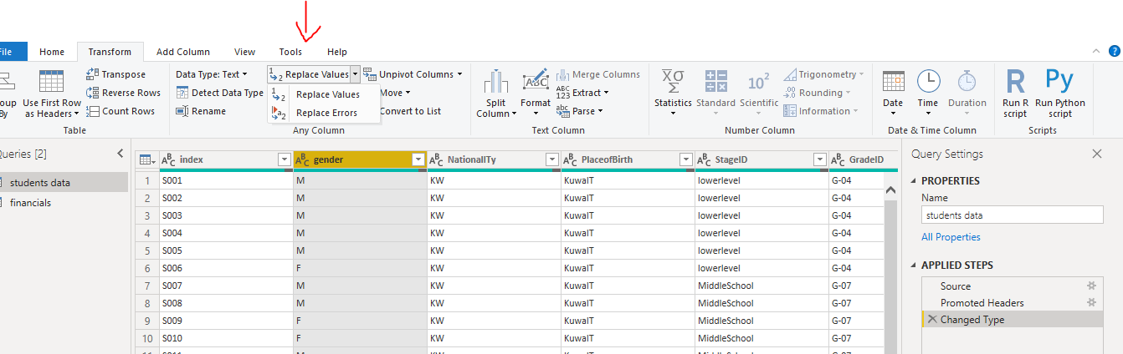

Note: This is a case sensitive approach.

Additional Material: [**Replace Values**](https://docs.microsoft.com/en-us/power-query/replace-values)

Demo exercise:

Question: Replace Gender M with Male and F with Female and observe the changes in Gender column.

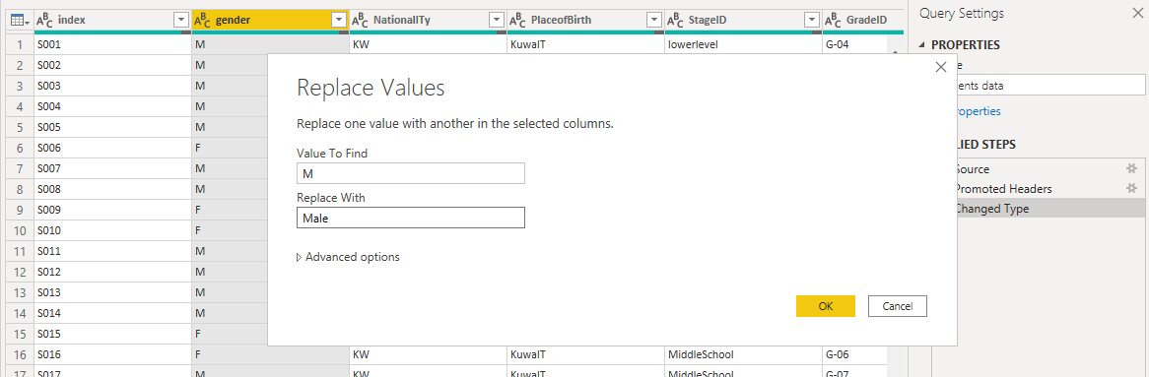

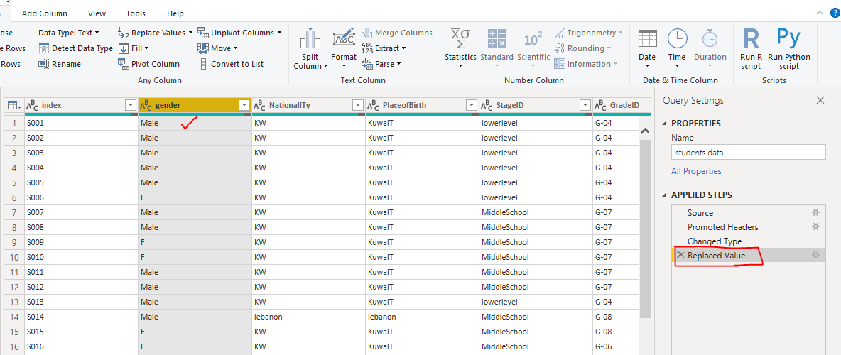

[Course](https://lms.codinginvaders.com/courses/course-v1:CodingInvaders+DATEST+1/course/) [Power BI Module 1](https://lms.codinginvaders.com/courses/course-v1:CodingInvaders+DATEST+1/course/#block-v1:CodingInvaders+DATEST+1+type@chapter+block@2c4c26b6002c466e8602380c081726e8) [Part 4 - Creating Report by combining all visuals](https://lms.codinginvaders.com/courses/course-v1:CodingInvaders+DATEST+1/course/#block-v1:CodingInvaders+DATEST+1+type@sequential+block@97de01bb0d3d45a287df1a1174ead15c) Demo with exercise to put all charts together into a single report

## **Demo with exercise to put all charts together into a single report**

Bookmark this page

A report is nothing but all visuals put together, so that data is now interpreted as a story.

It is important to understand how each chart interacts when combined.

**Demo Exercise:**

**Question:** An authority from school wants to monitor survey report that contains following information,

1. Perform Data Cleansing (Duplicate removal and treat blank rows) as the initial step.
2. Number of surveys answered by parents and how many were answered by students
3. Number of students absent for more than 7 days & less than 7 days by each gender type.
4. Total count of students that belong to each grade.
5. Total number of students that are studying in different stages, how many parents among these are satisfied with the school and its management.
6. This report must be able to filter data based on Nationality and Place of birth.

**Instruction :** Create a new file > load data > cleanse data >create chart

**Guided Exercise:**

**Assignment:**

The Store Manager is in need of a report to monitor sales and order. Requirements to create the same are given below, choose any charts to create visuals with a minimum of 1 Pie/ Donut Chart.

1. Treat duplicate removal and eliminate blank row removal as the initial step as the data is loaded.
2. Create a chart to keep track of the number of invoices being paid by different Payment methods.
3. Create a chart to calculate total gross income by each city.
4. Create a chart to calculate total sales by each month.
5. Create a chart to calculate total sales by each product.
6. Create a slicer to filter values by each branch.
7. Create a slicer to filter values by gender type.

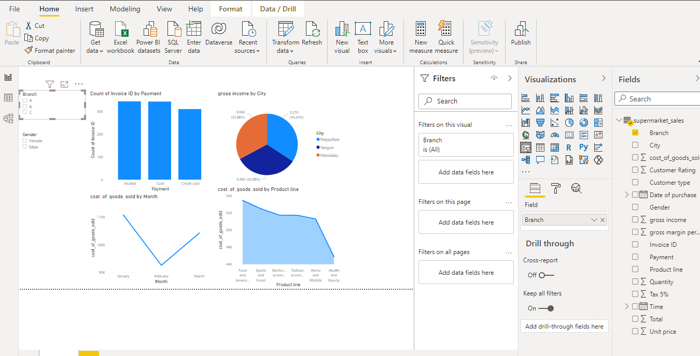

Apply filter on Branch “C” and answer the following Questions.

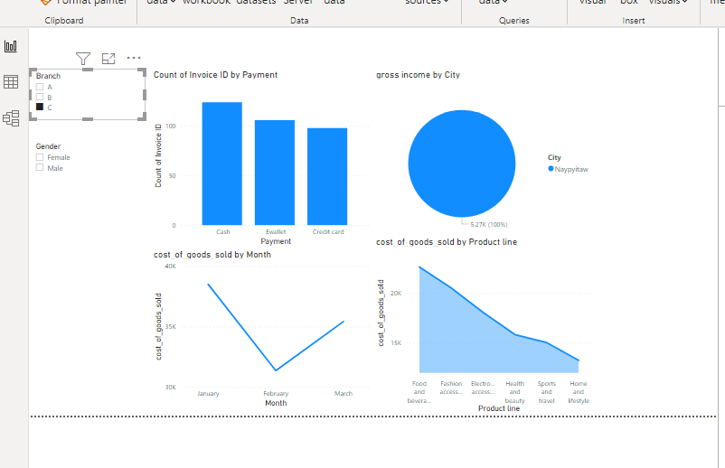

### Question 1

1 point possible (graded)

How many invoices have been settled using a credit card?

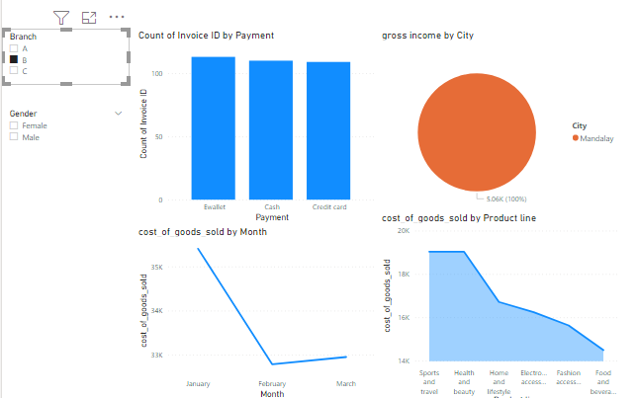

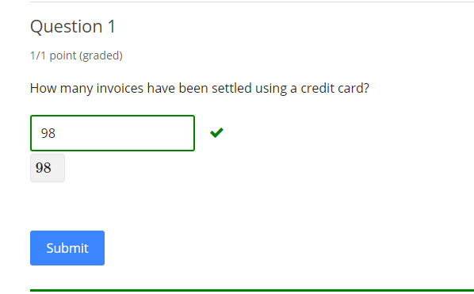

Submit

Some problems have options such as save, reset, hints, or show answer. These options follow the Submit button.

### Question 2

1 point possible (graded)

Which Product category has made the highest sales?

Home and Lifestyle

Health and Beauty

Food and Beverages

Sports and Travel

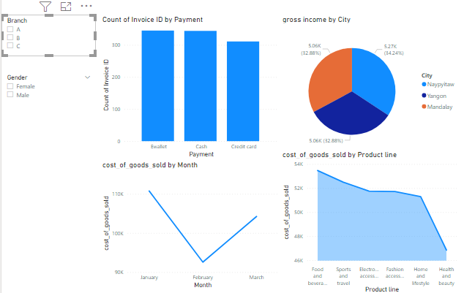

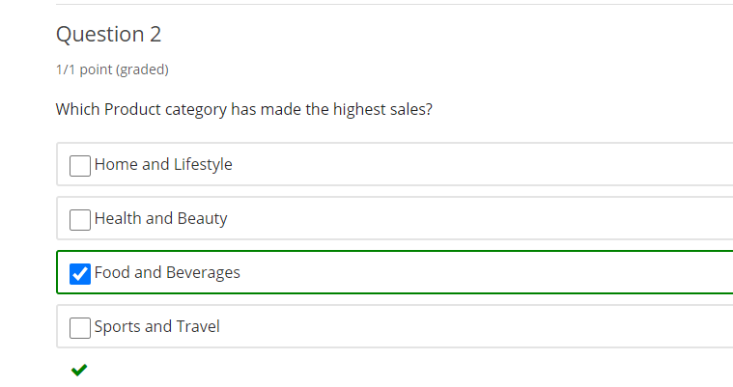

Submit

Some problems have options such as save, reset, hints, or show answer. These options follow the Submit button.

### Question 3

1 point possible (graded)

Which month the store has performed best?

January

February

March

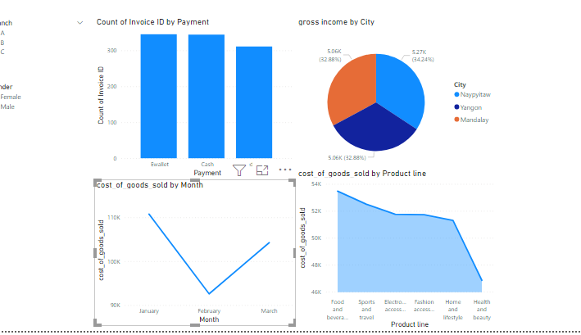

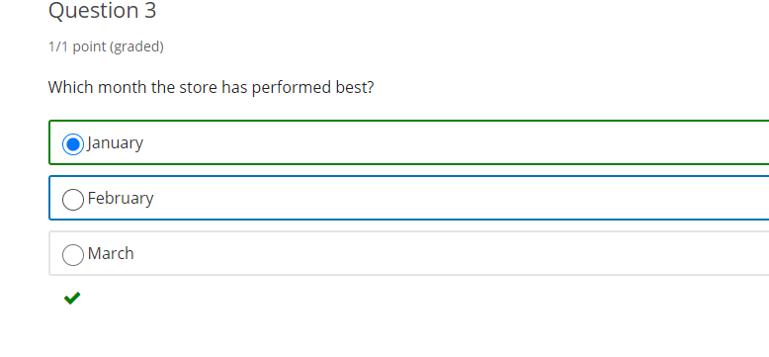

Submit

Some problems have options such as save, reset, hints, or show answer. These options follow the Submit button.

### Question 4

1 point possible (graded)

How many Cities belong to Branch “C”?

Hint

Submit

Some problems have options such as save, reset, hints, or show answer. These options follow the Submit button.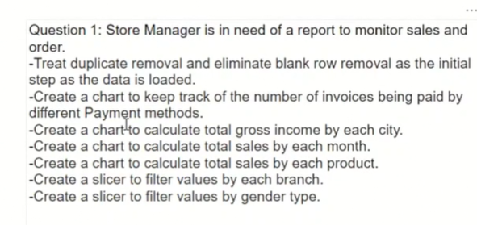

[Course](https://lms.codinginvaders.com/courses/course-v1:CodingInvaders+DATEST+1/course/) [Power BI Module 1](https://lms.codinginvaders.com/courses/course-v1:CodingInvaders+DATEST+1/course/#block-v1:CodingInvaders+DATEST+1+type@chapter+block@2c4c26b6002c466e8602380c081726e8) [Part 5 - Capstone Project Power BI 1](https://lms.codinginvaders.com/courses/course-v1:CodingInvaders+DATEST+1/course/#block-v1:CodingInvaders+DATEST+1+type@sequential+block@246e57c82a9b49b993a916ed789d98fd) Power BI 1 Capstone Project

## **Power BI 1 Capstone Project**

Bookmark this page

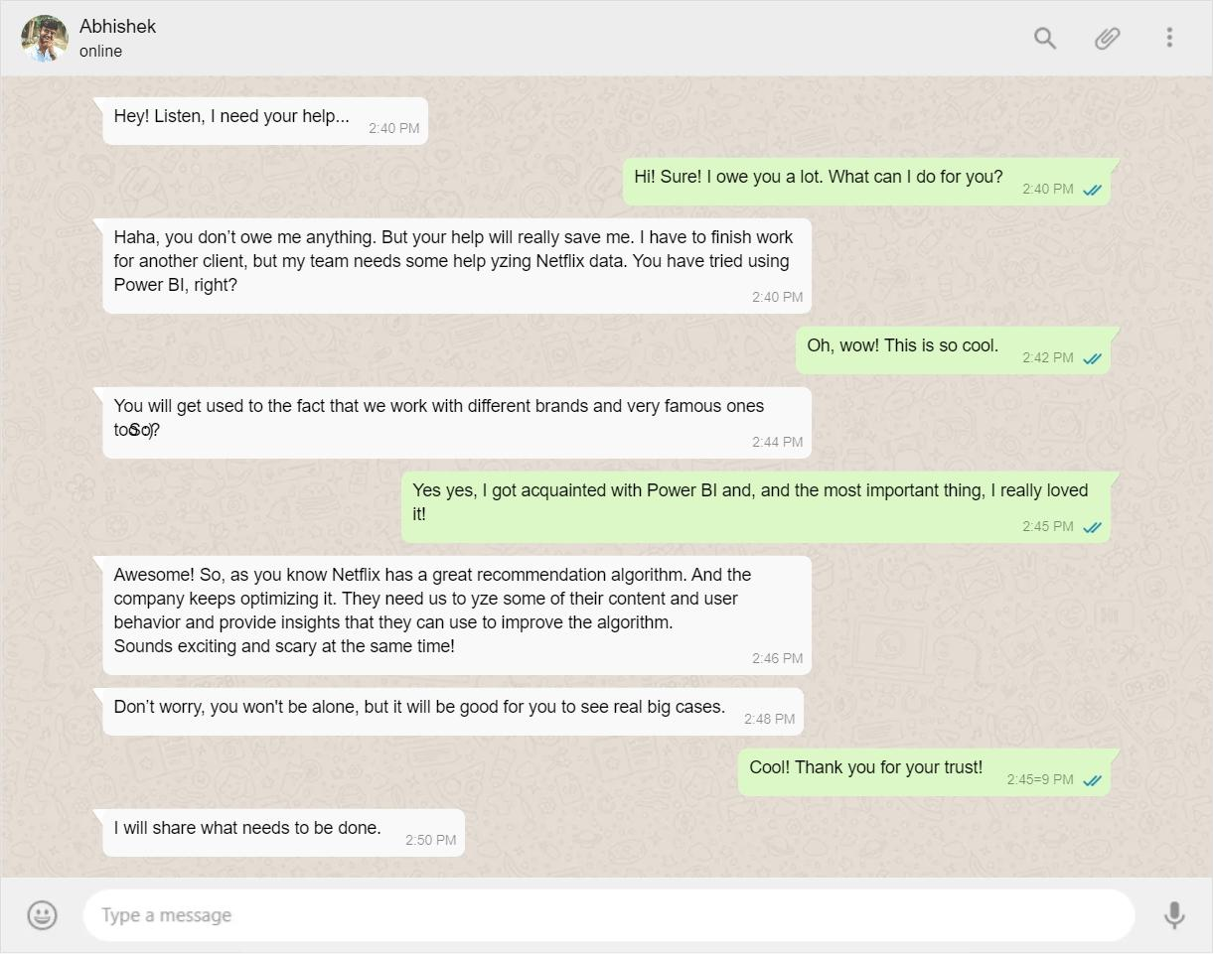

**Dataset Description**

Netfilx_titles - This table contains Netflix TV and Movie shows details like year of release, date when added to OTT platform, country, Casting crew, Directing crew, Genre of the show, duration, suitable audience ratings, and description of the show.

Download the dataset from [**here**](https://lms.codinginvaders.com/assets/courseware/v1/cbe84758abdd517ec7f376644972b5fb/asset-v1:CodingInvaders+DATEST+1+type@asset+block/netflix_titles.csv).

**Business problem**

A Netflix associate wants to understand the frequency of shows being released on Netflix, what are the popular genres, how are the shows rated, etc. They also want to understand these aspects based on different dates it gets released on the Netflix Platform and compares stats based on Movies or TV Shows alone.

Instructions to solve these assignments,

* Create a Power BI file (.pbix) and connect it to this dataset.
* All these assignments should be created on the same file, by creating visuals on same page for each assignment ( except for Assignment1 )
* Assignment 1 should be performed as the initial step.
* Save and Submit the file after completion [**here.**](https://forms.gle/XnnYzijhN71KCaFc7)

### Assignment 1

1 point possible (graded)

Perform Data cleansing on Netflix dataset and remove some of the data impurities,

1. Clean the duplicates from Table

2. Remove Blank Rows

3. Type of show should be either a “Movie” or “TV Show” only. Filter out all other unrelated values.

4. Ensure that “Date added” does not have any blank value. Filter NULL values.

Count the number of rows performing all above operations, and submit the result.

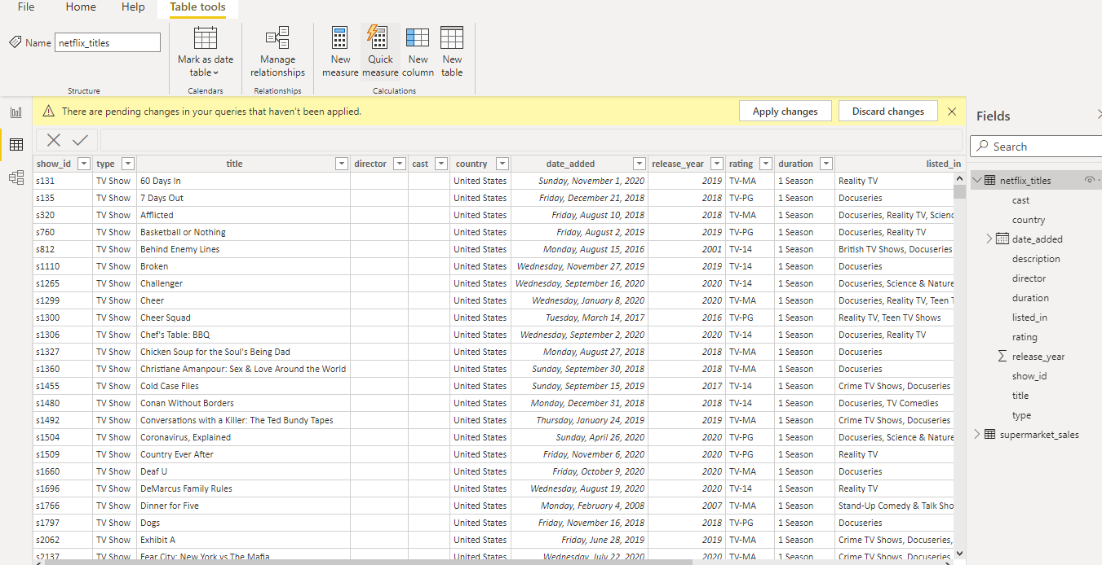

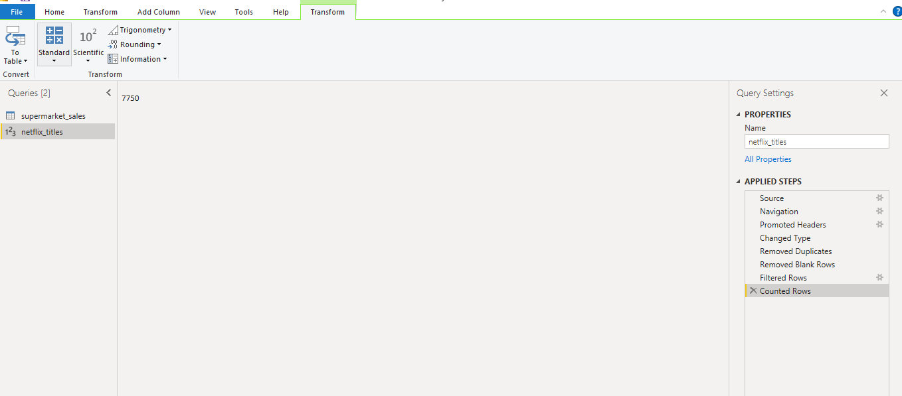

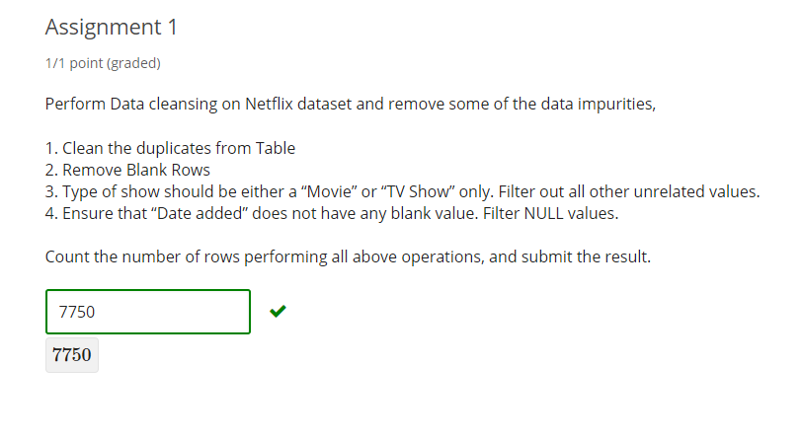

1. Hint (1 of 1): After obtaining row count, Delete the “Counted rows” step and apply all changes

Next Hint

Review

Hint

Submit

Some problems have options such as save, reset, hints, or show answer. These options follow the Submit button.

### Assignment 2

1 point possible (graded)

Netflix associate wants to find out the number of shows released in each genre. Create a bar chart and find out how many Shows are listed as Documentaries.

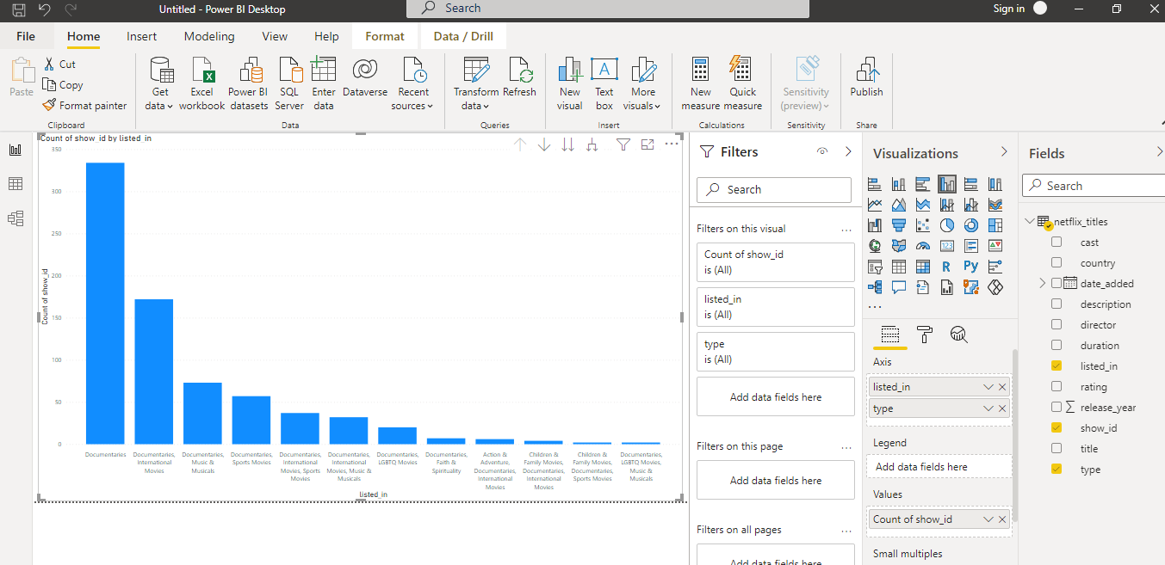

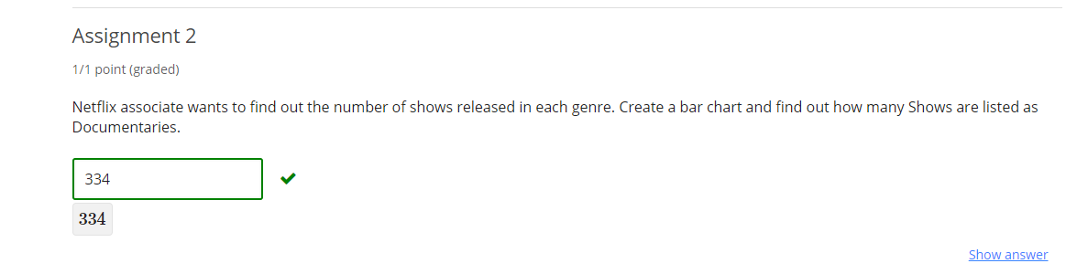

Submit

Some problems have options such as save, reset, hints, or show answer. These options follow the Submit button.

### Assignment 3

1 point possible (graded)

The Associate wants to find out what is the overall count of Movies and TV Shows. Find out how is the data distributed and find the percentage of Movies in Netflix when compared to TV Shows. (Answer with % sign)

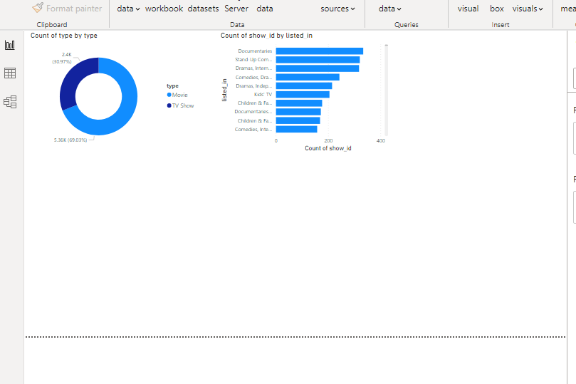

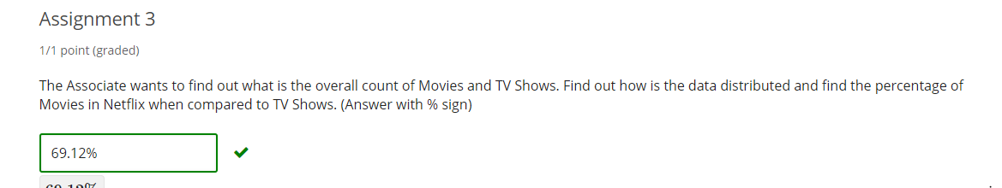

1. Hint (1 of 1): Create a Donut chart

Next Hint

Review

Hint

Submit

Some problems have options such as save, reset, hints, or show answer. These options follow the Submit button.

### Assignment 4

1 point possible (graded)

The netflix associate wants to understand about show ratings on Netflix. He wants to find out how all shows are categorised based on the ratings. Also he wants it to be filtered based on Movies, TV Shows or both.

Create a column chart and find how many Movie shows in total are rated as “TV-MA”? (TV-MA means Suitable only for Mature Audience)

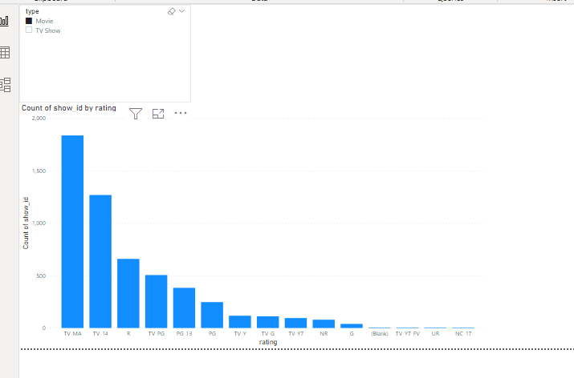

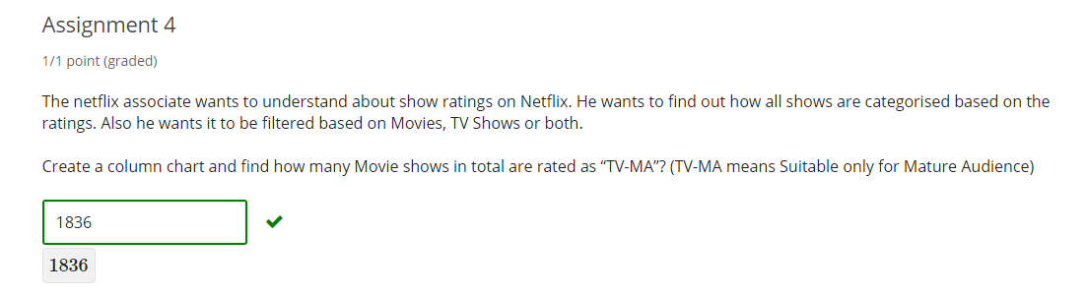

1. Hint (1 of 1): Create a horizontal slicer

Next Hint

Review

Hint

Submit

Some problems have options such as save, reset, hints, or show answer. These options follow the Submit button.

### Assignment 5:

2 points possible (graded)

The Netflix associate wants to know the total count of shows released each month for each type( Movie and TV shows) separately. Additionally he wants it to be able to filter based on range of dates. Use a **Stacked chart/ Clustered column chart** for this exercise.

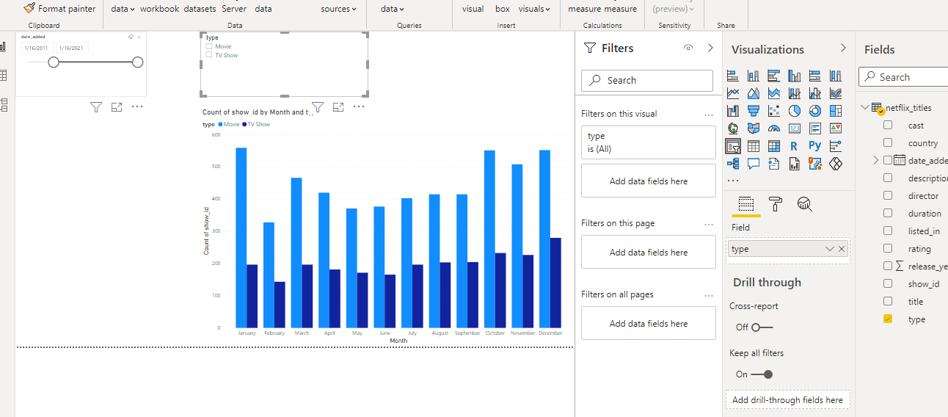

**Question 1:** What are the total number of TV shows released in the month of May?

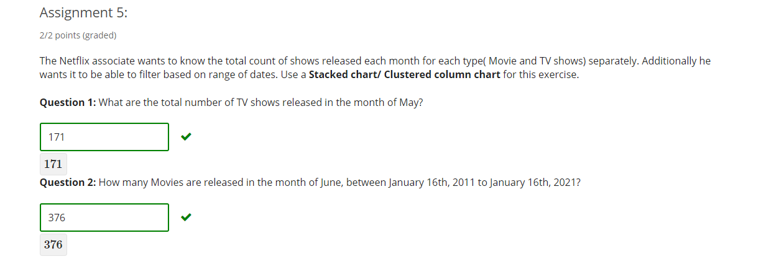

**Question 2:** How many Movies are released in the month of June, between January 16th, 2011 to January 16th, 2021?



Submit

Some problems have options such as save, reset, hints, or show answer. These options follow the Submit button.

### Assignment 6

1 point possible (graded)

The netflix associate wants to compare total number of shows vs distinct number of genres released each month. Create a line chart to find out how many unique genres are released in the month of January.

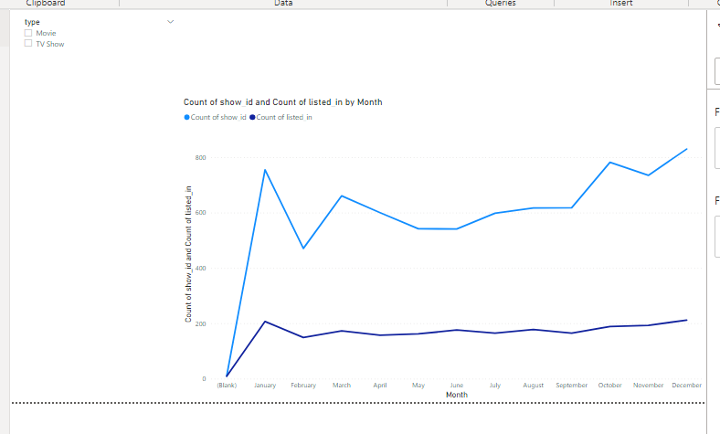

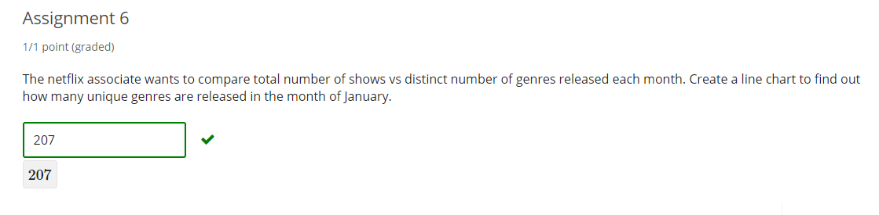

1. Hint (1 of 1): Use Count of Distinct for genres.

Next Hint

Review

Hint

Submit

Some problems have options such as save, reset, hints, or show answer. These options follow the Submit button.

Assignment 7:

Save the file with all the visuals created from above requirements and submit the .pbix file [**here.**](https://forms.gle/XnnYzijhN71KCaFc7)

